Time Series Analysis:

<https://www.youtube.com/watch?v=DeORzP0go5I&list=PLvcbYUQ5t0UHOLnBzl46_Q6QKtFgfMGc3&index=2>

<https://www.youtube.com/watch?v=Lh9LY5YoH0I&list=PLqYFiz7NM_SMC4ZgXplbreXlRY4Jf4zBP>

<https://www.youtube.com/watch?v=DtCPLDuzk8M&list=PLmPJQXJiMoUVr07-VnwDiki89DqyuSS21>

<https://www.youtube.com/watch?v=-r7wB9DJtiU&list=PL3N9eeOlCrP5cK0QRQxeJd6GrQvhAtpBK>

<https://www.youtube.com/watch?v=CAT0Y66nPhs>

<https://www.youtube.com/watch?v=gFI4Dj7tdsI&list=PL27amhF9jj-Ku47tMX9-Kh1GubWJYltcb&index=25>

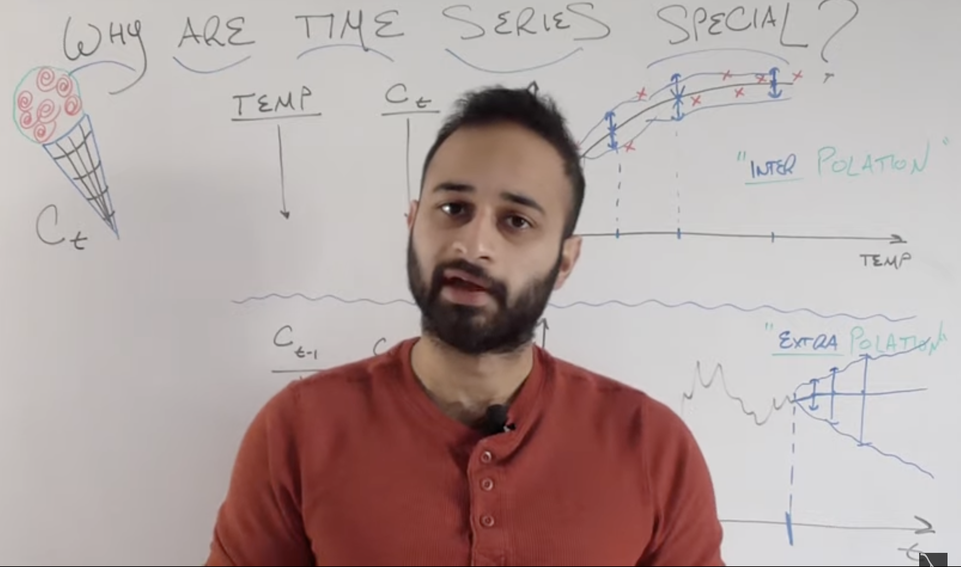

* In normal regression we use interpolation and in time series we use extrapolation.

ACF vs PACF:

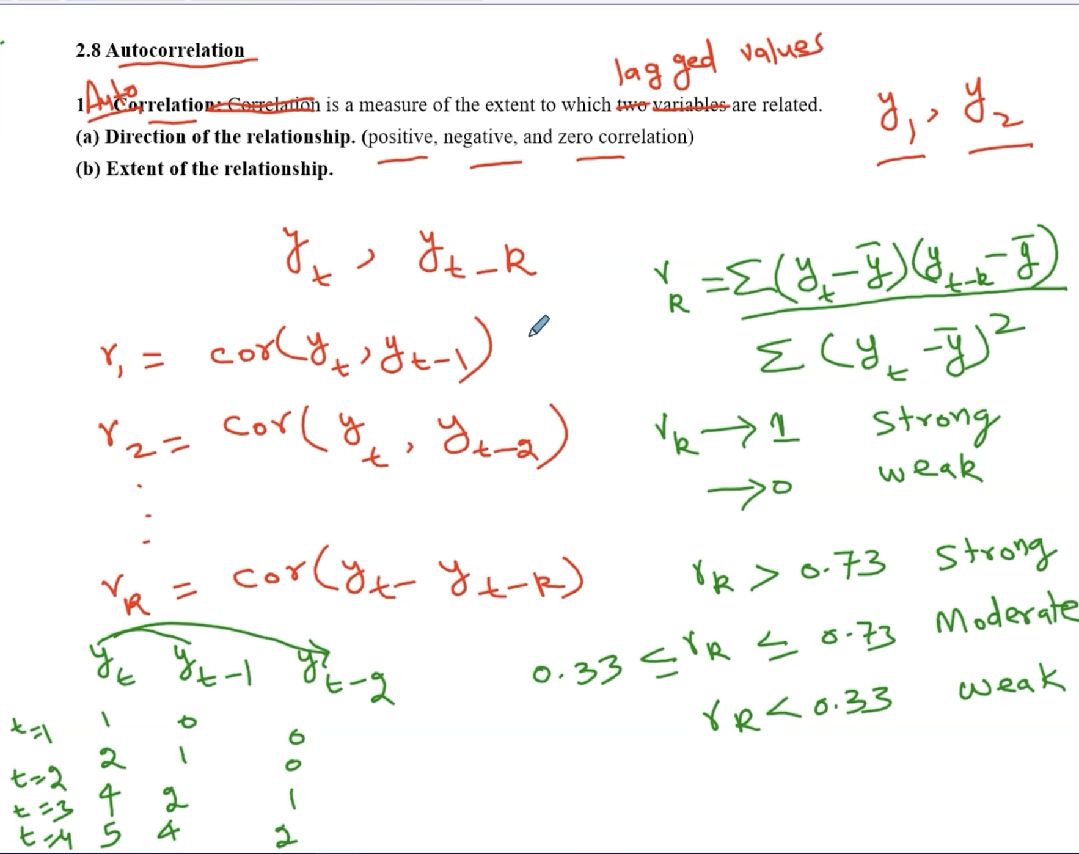

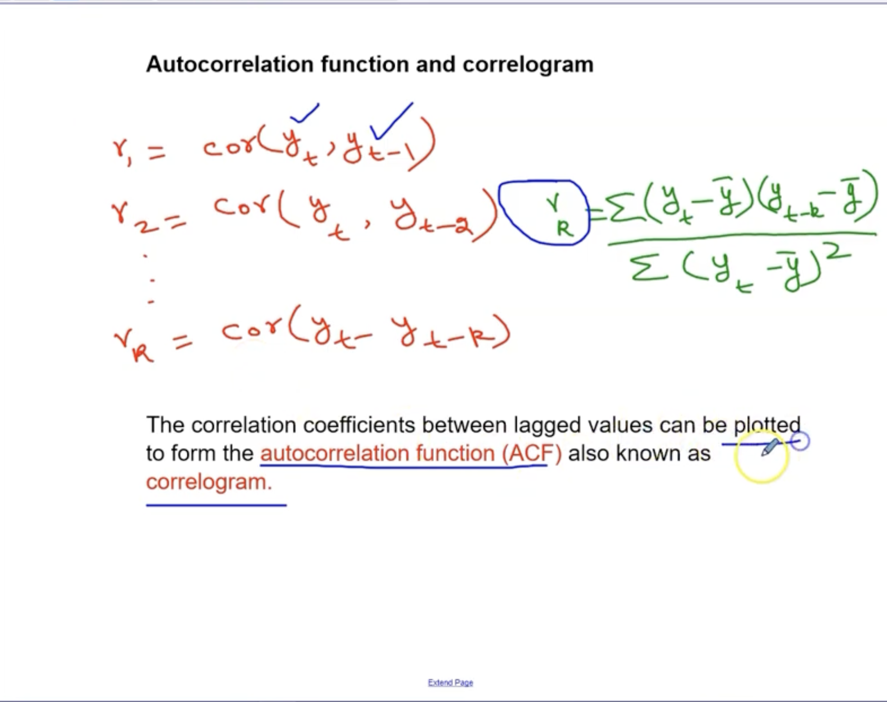

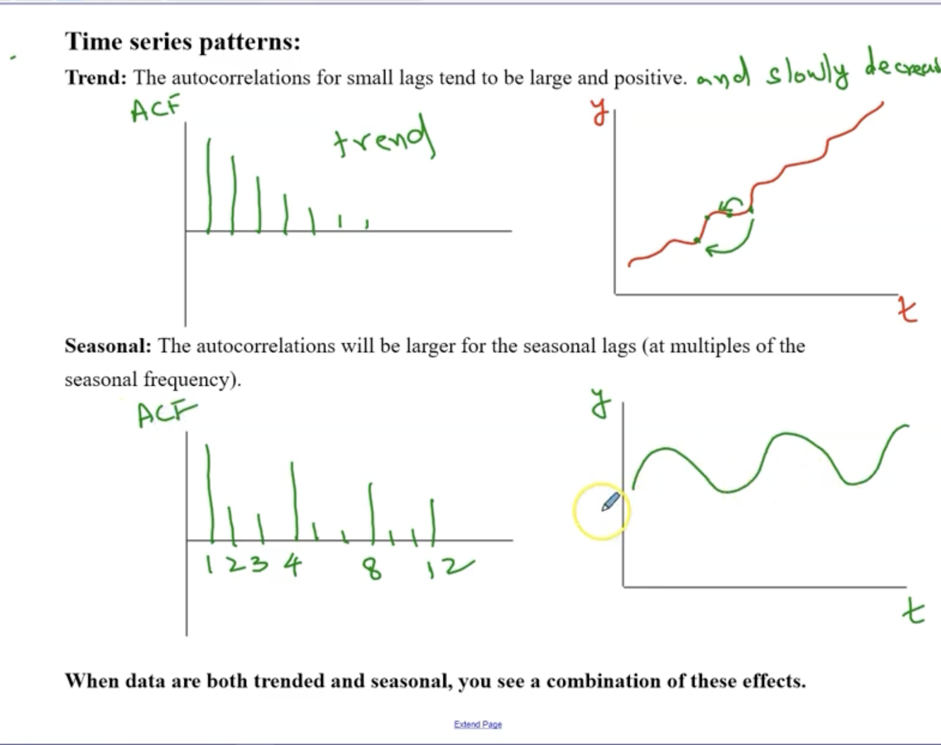

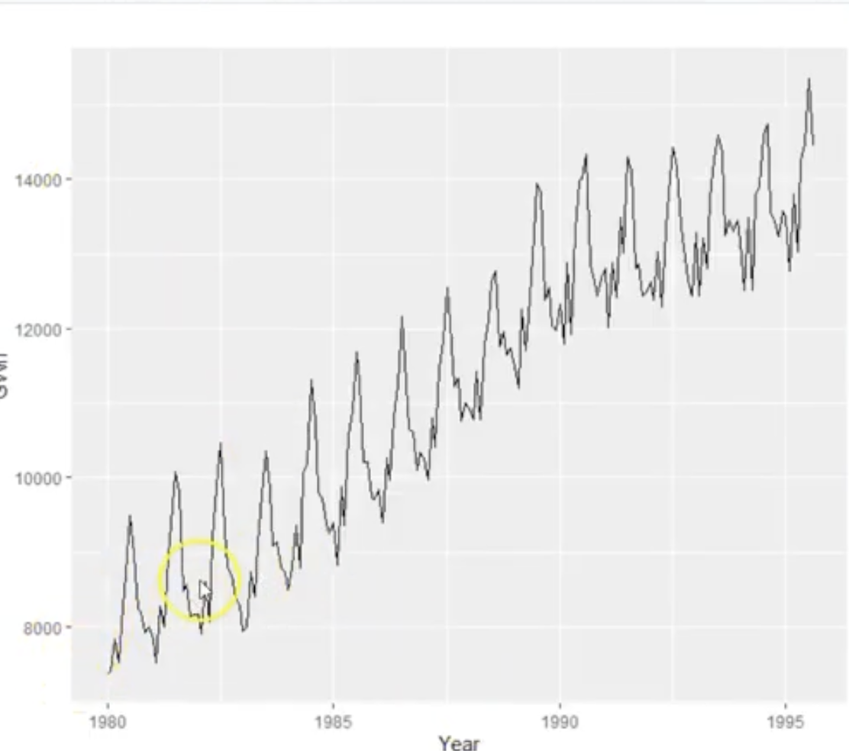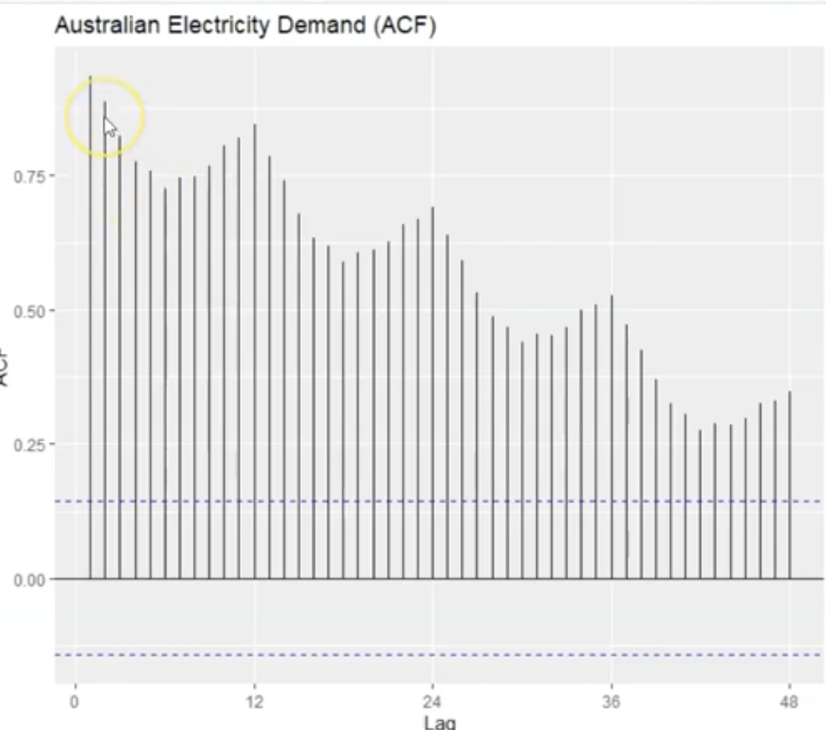

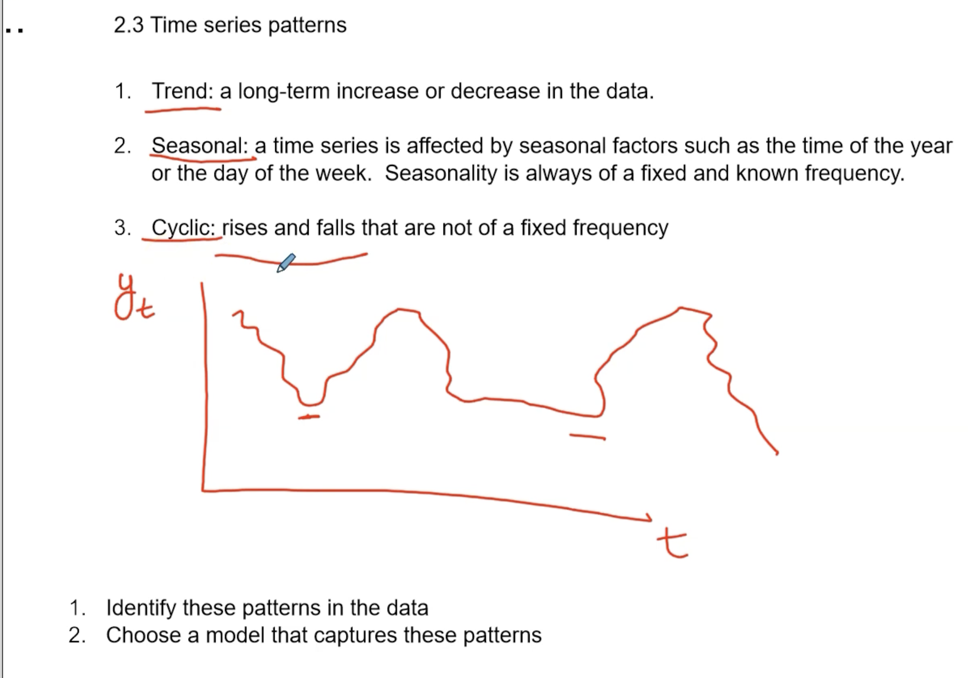

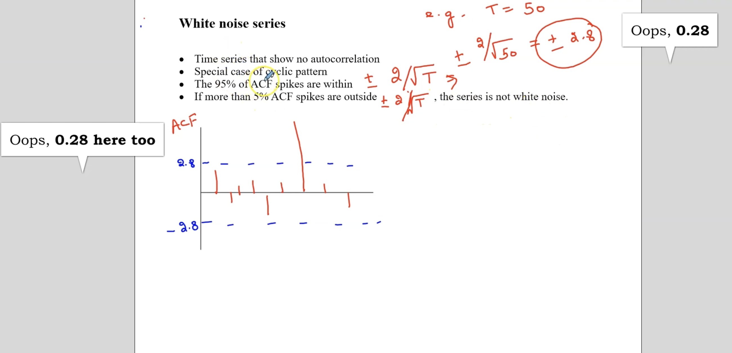

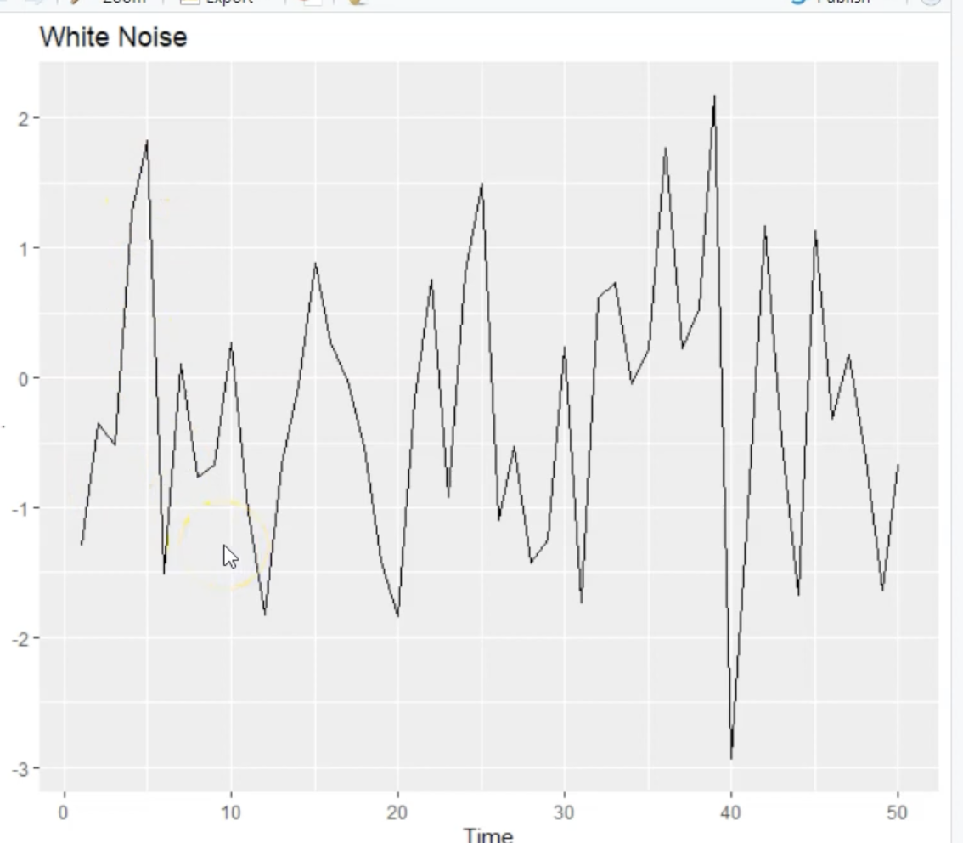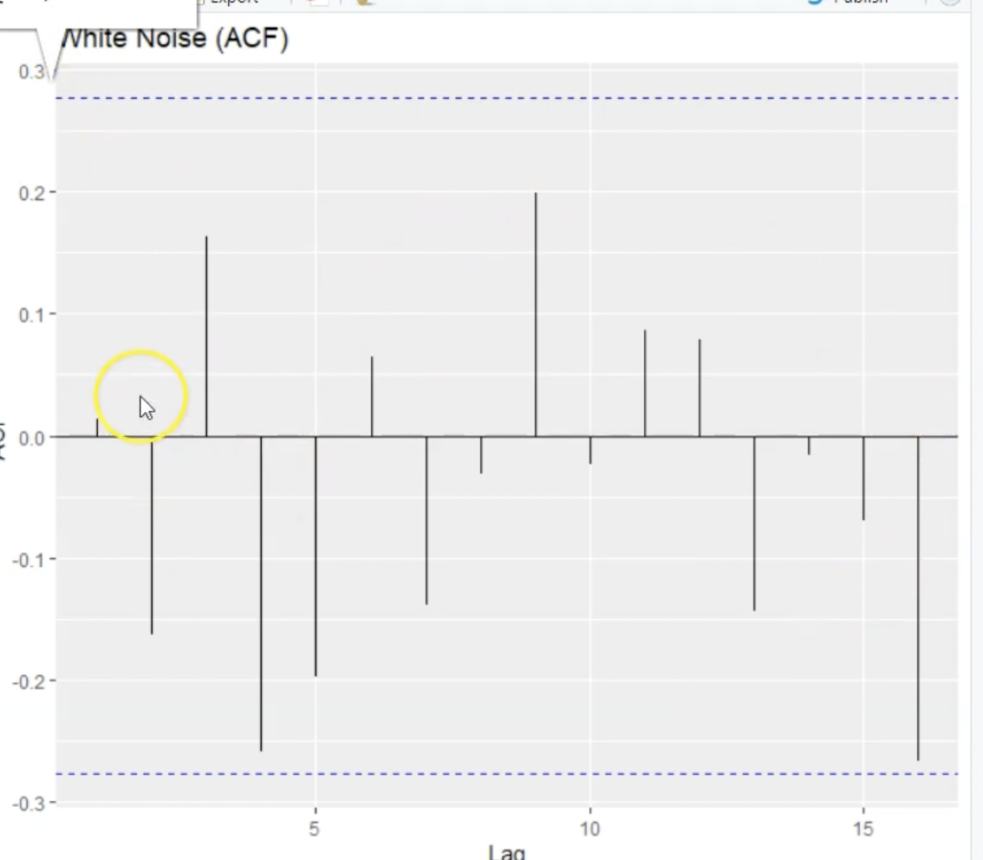

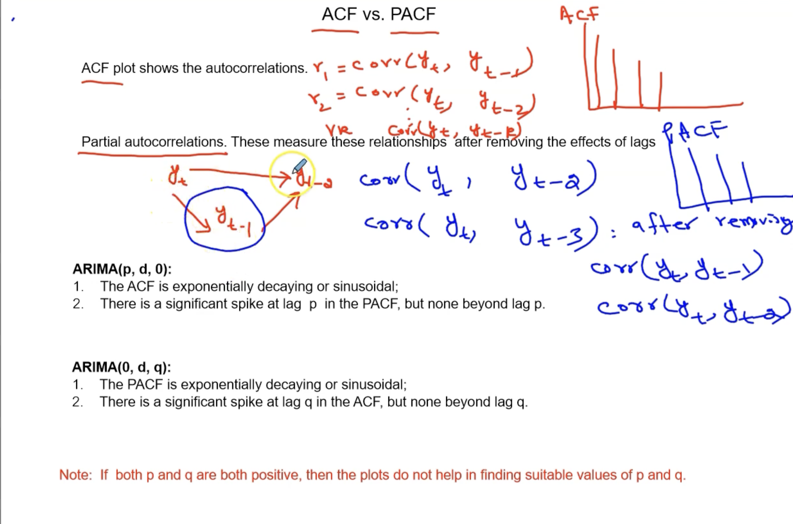

Stationarity:

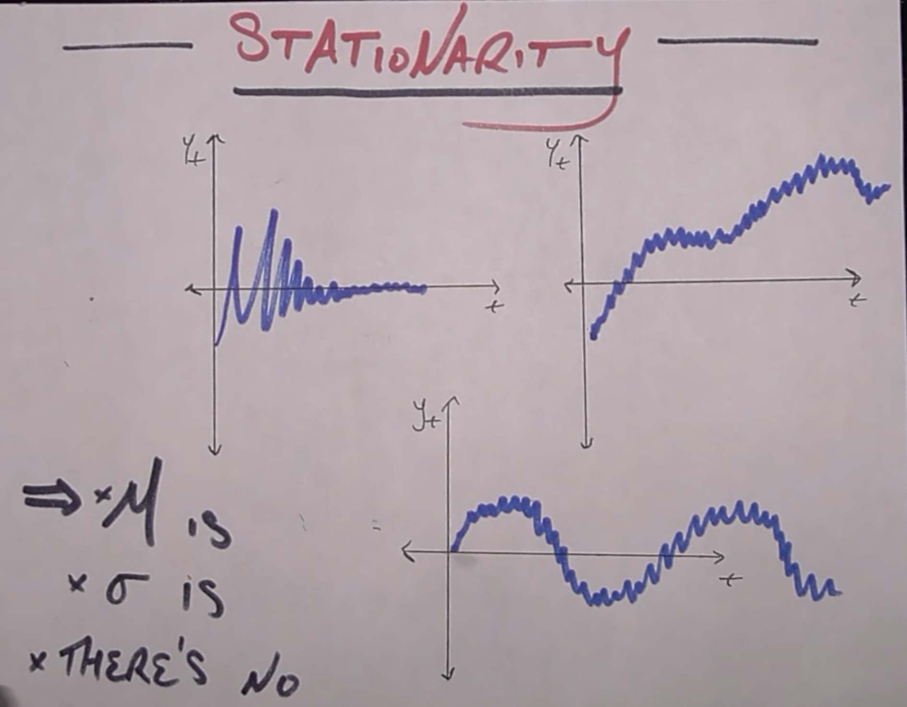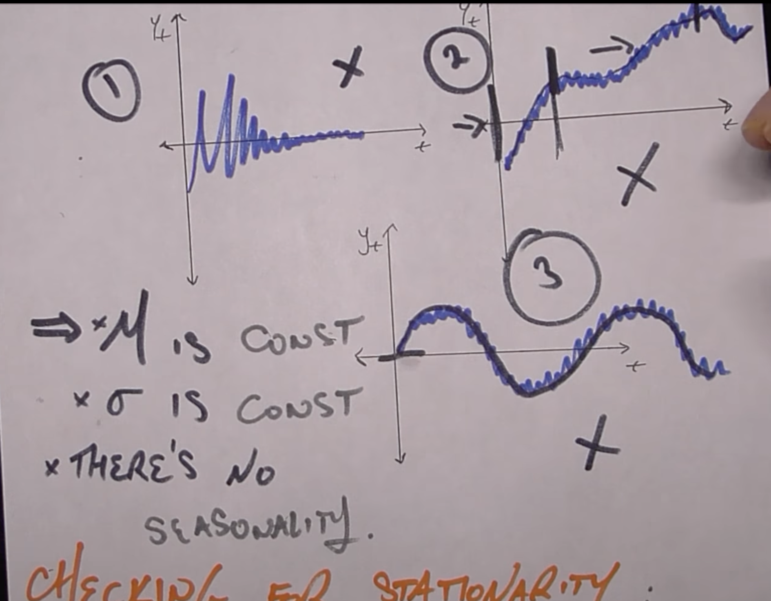

* Stationarity means there means are constant, variance/standard deviation is constant, there is no seasonality.
* White noise is stationary where it mean is 0, but not all stationary plots are white noise.

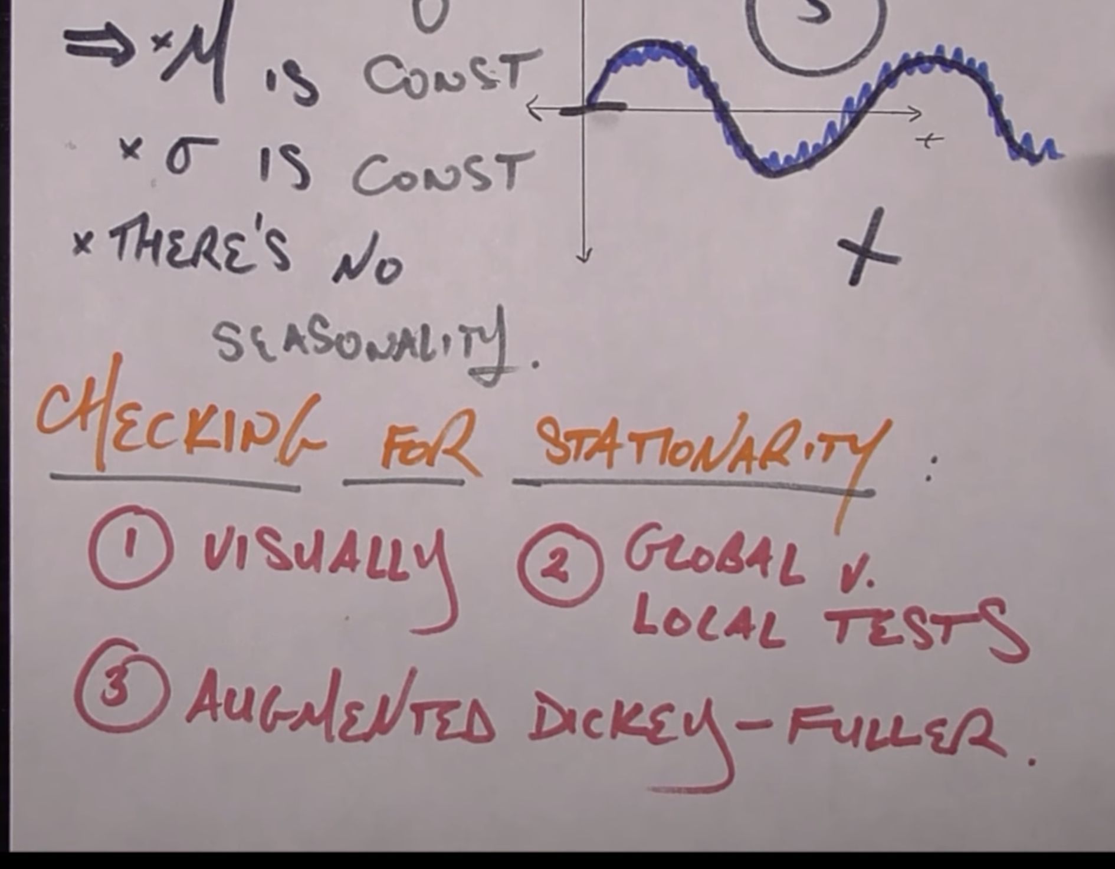

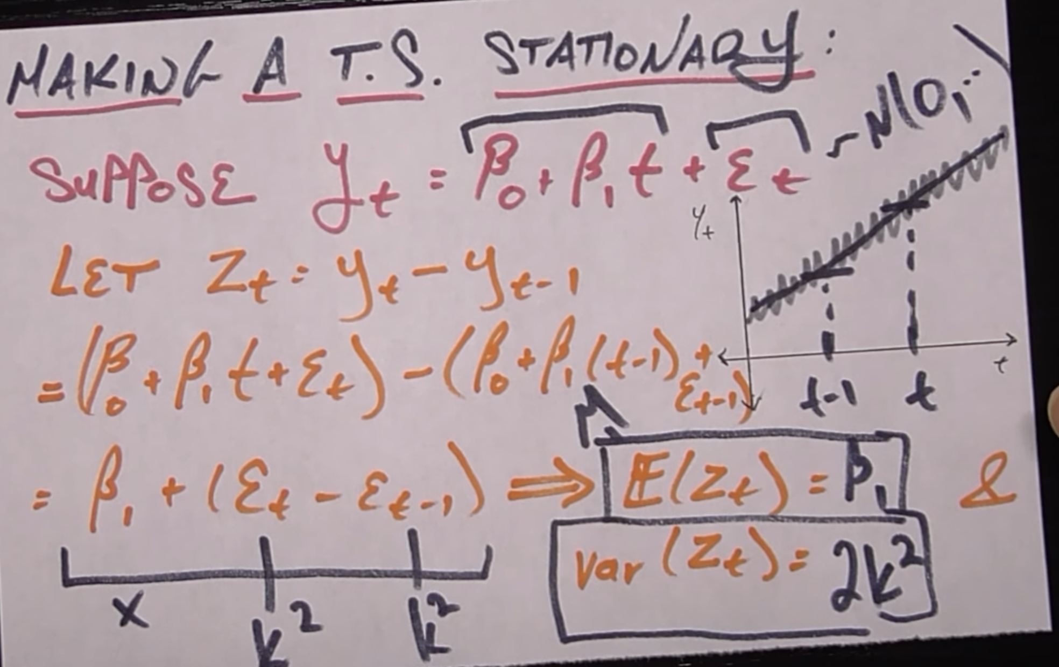

Units Roots:

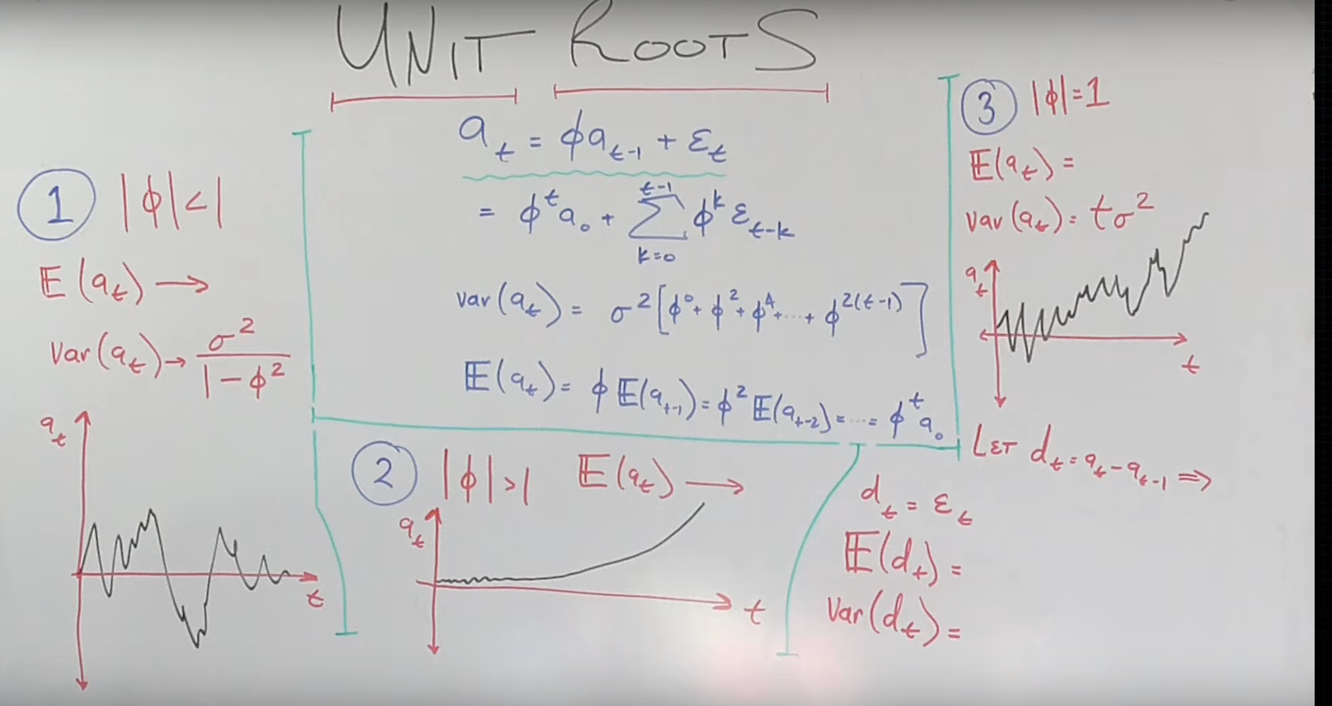

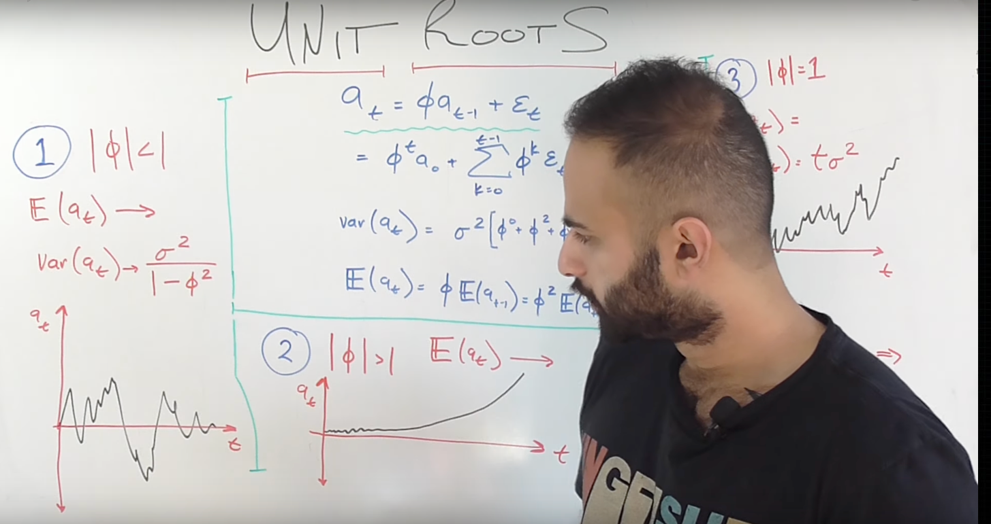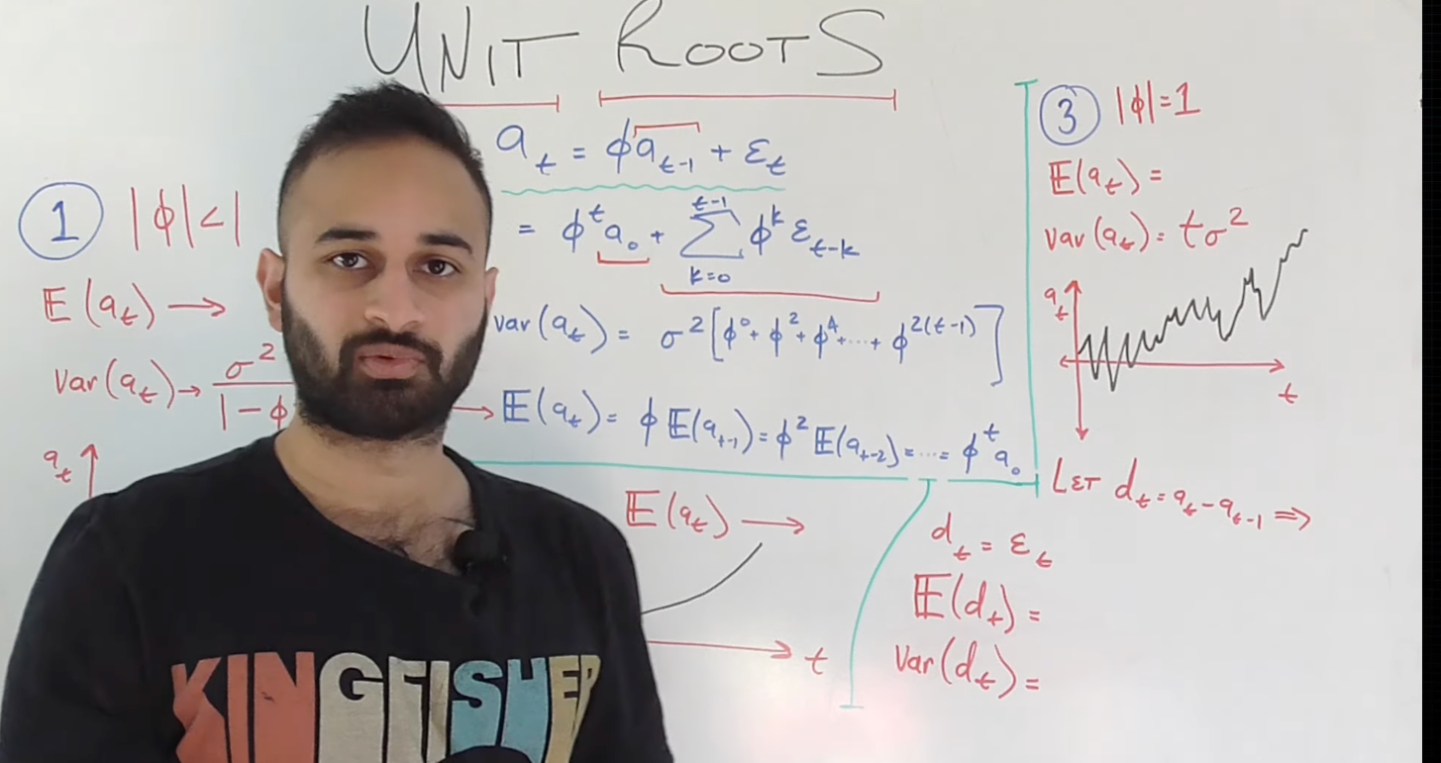

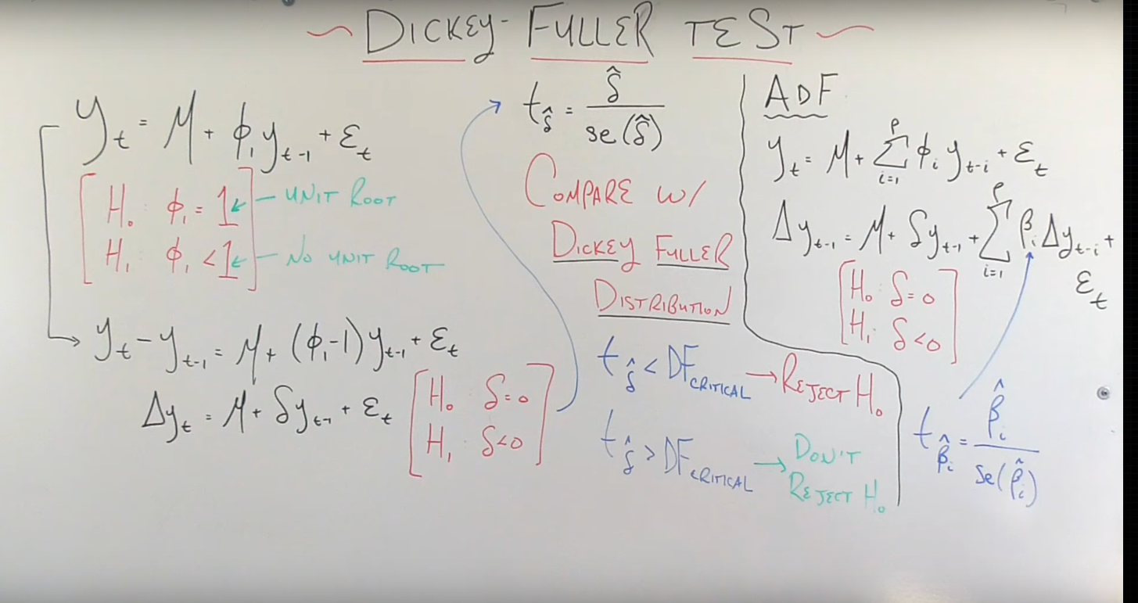

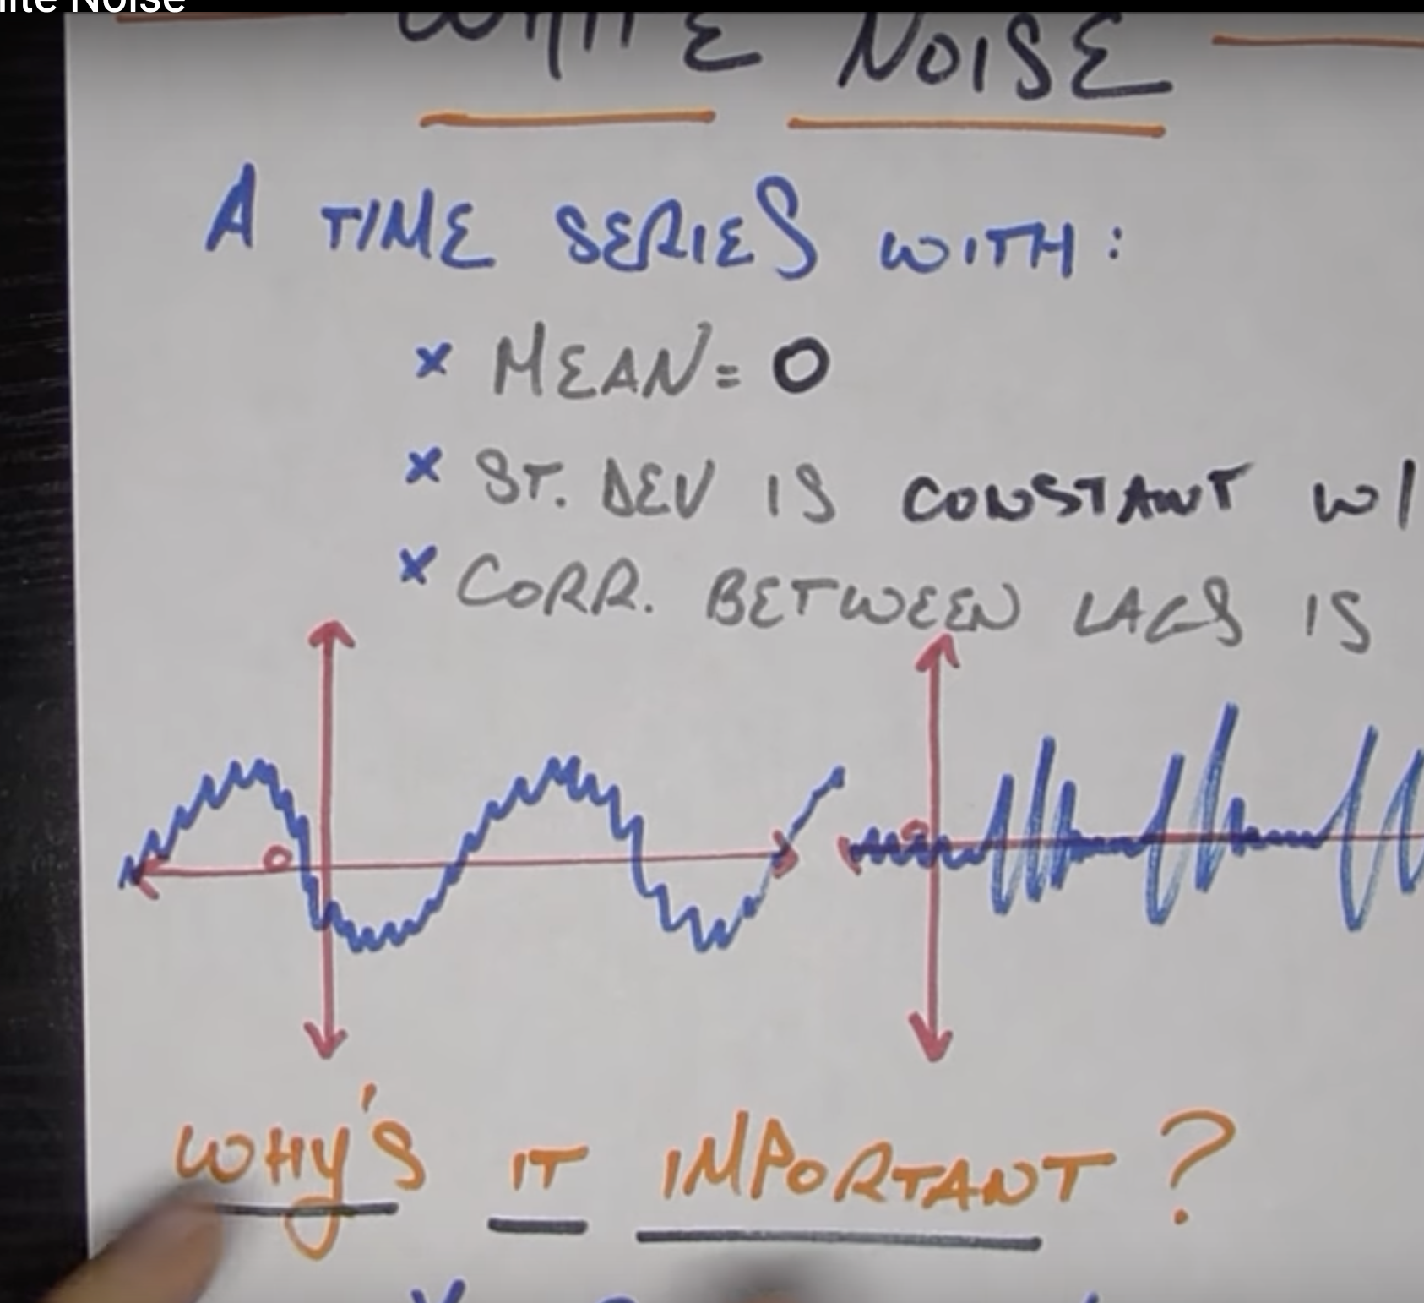

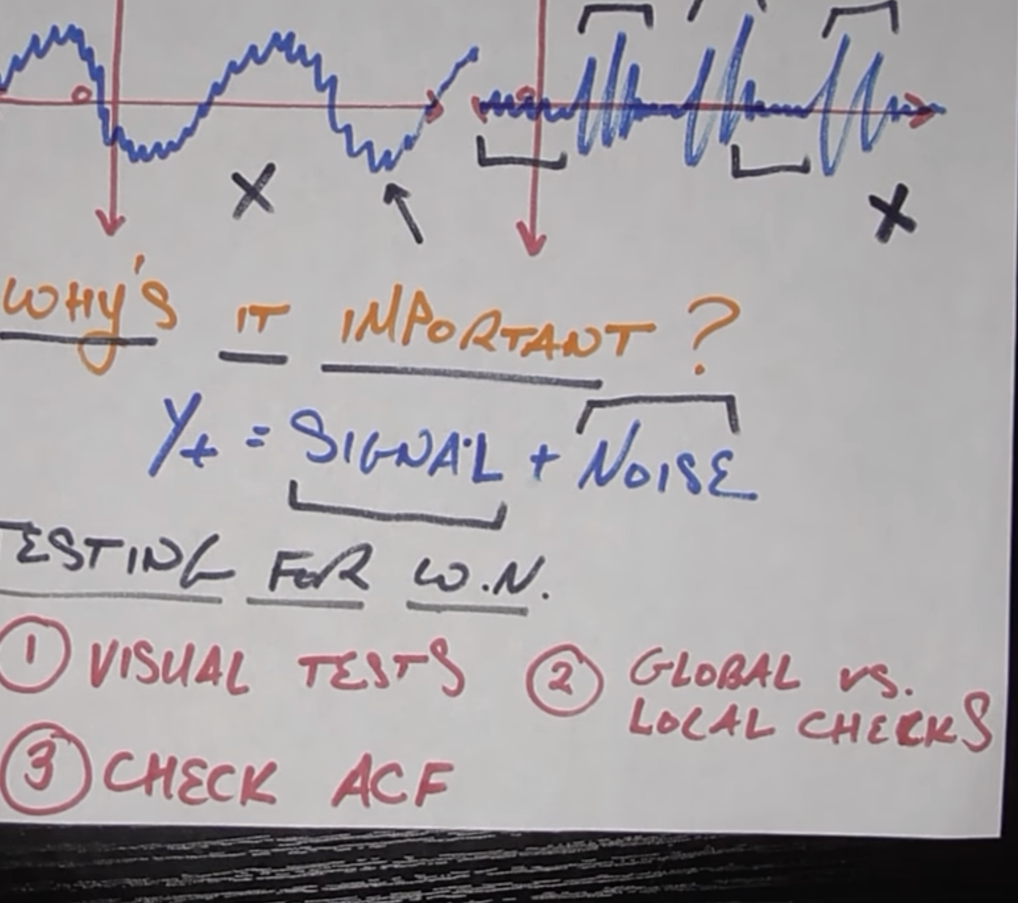

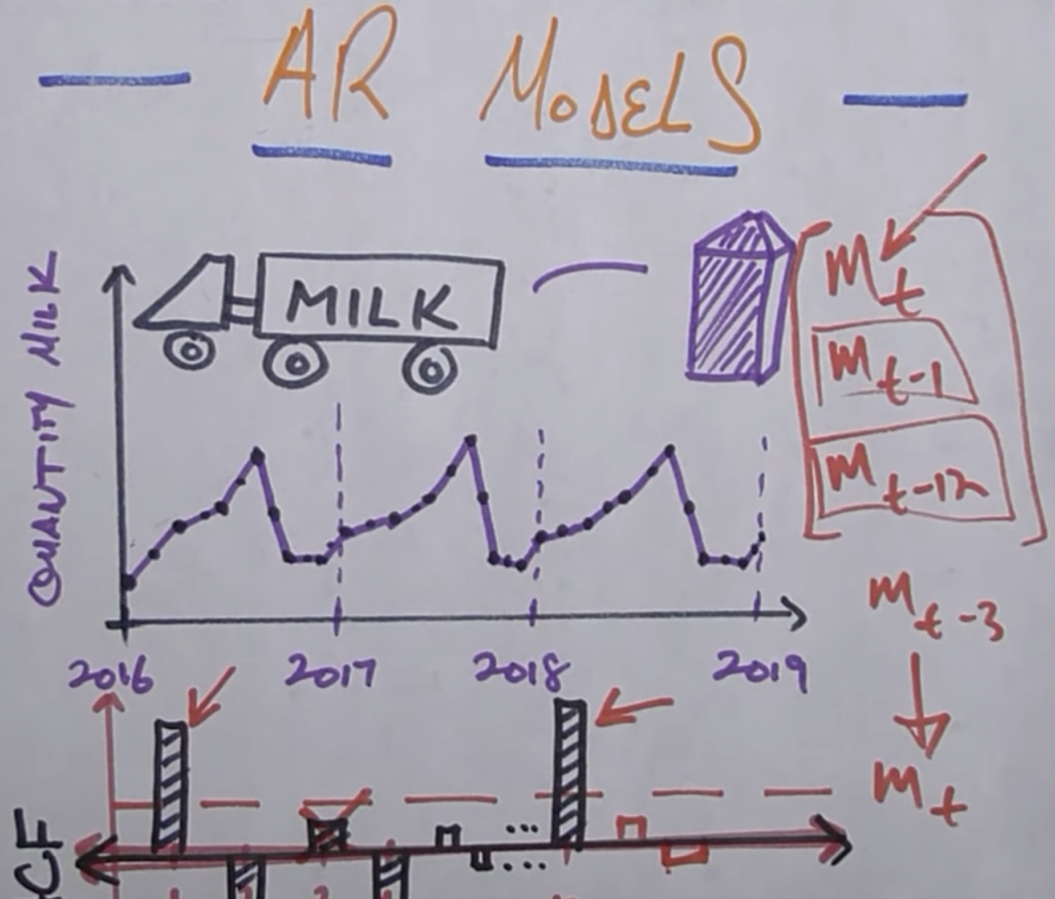

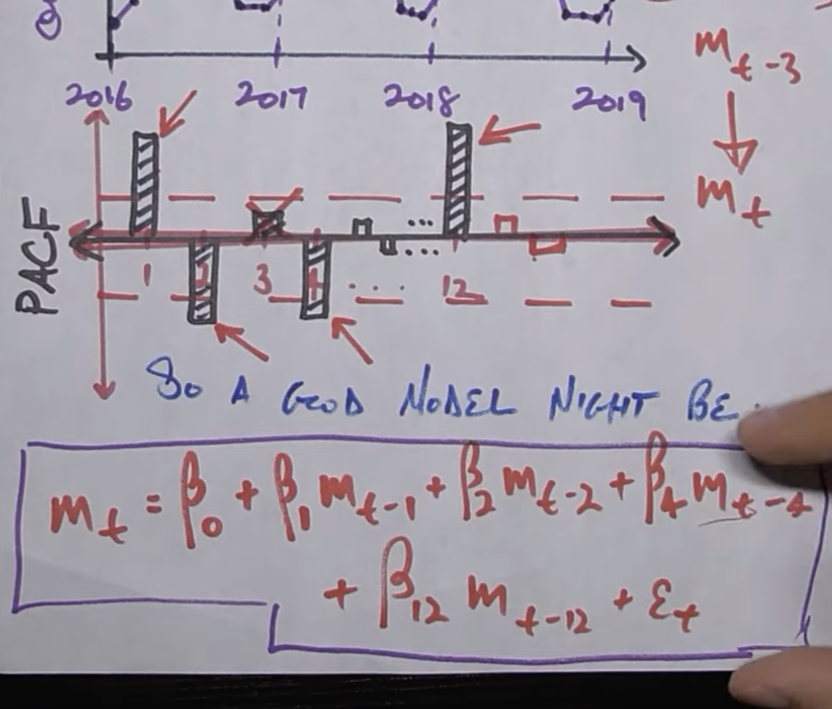

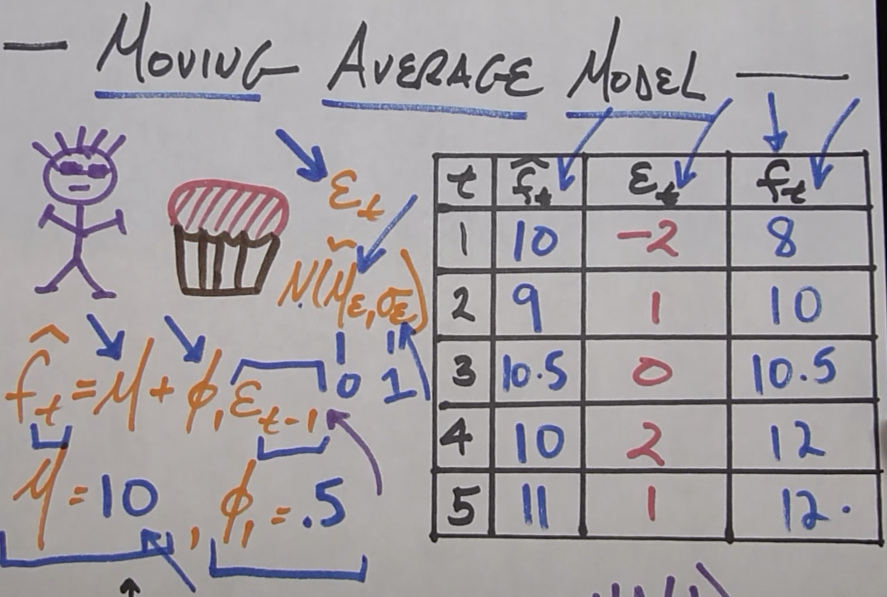

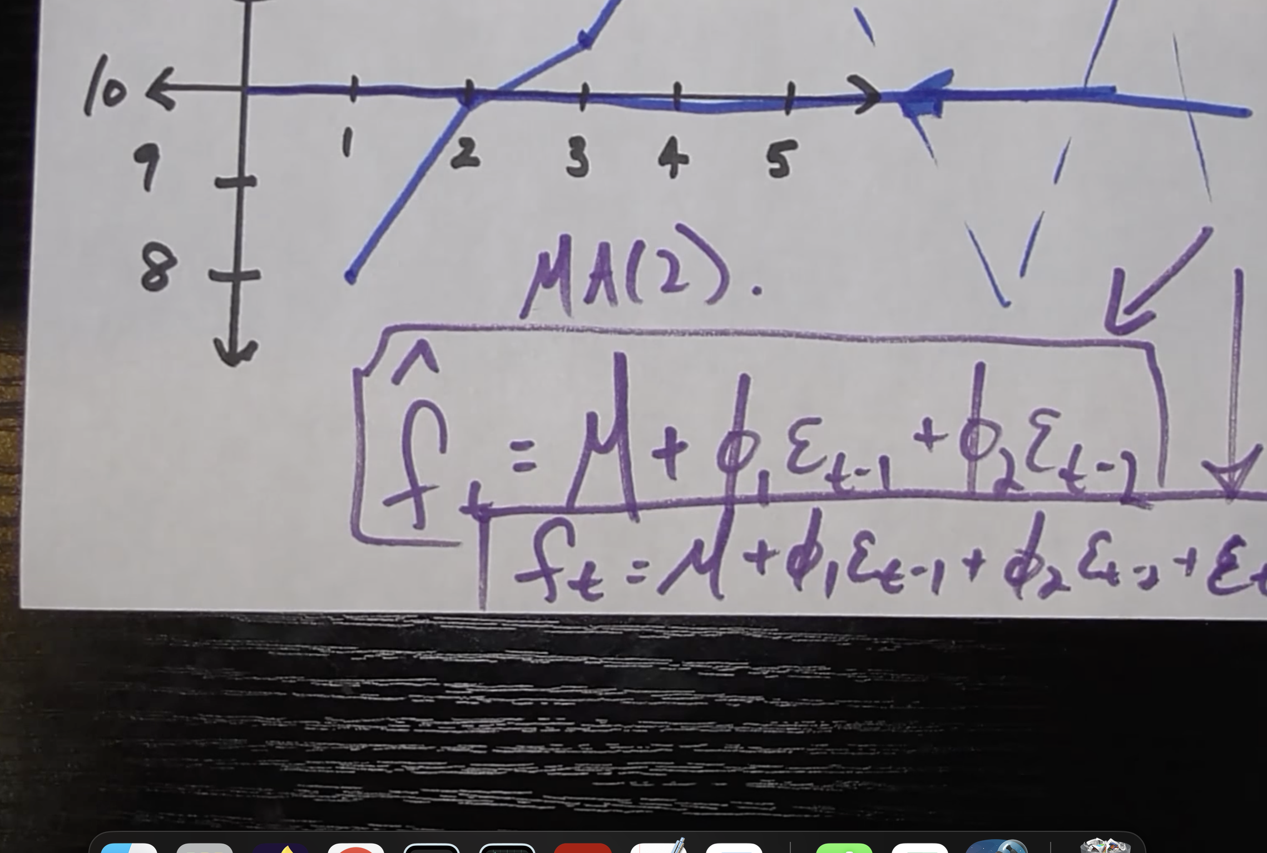

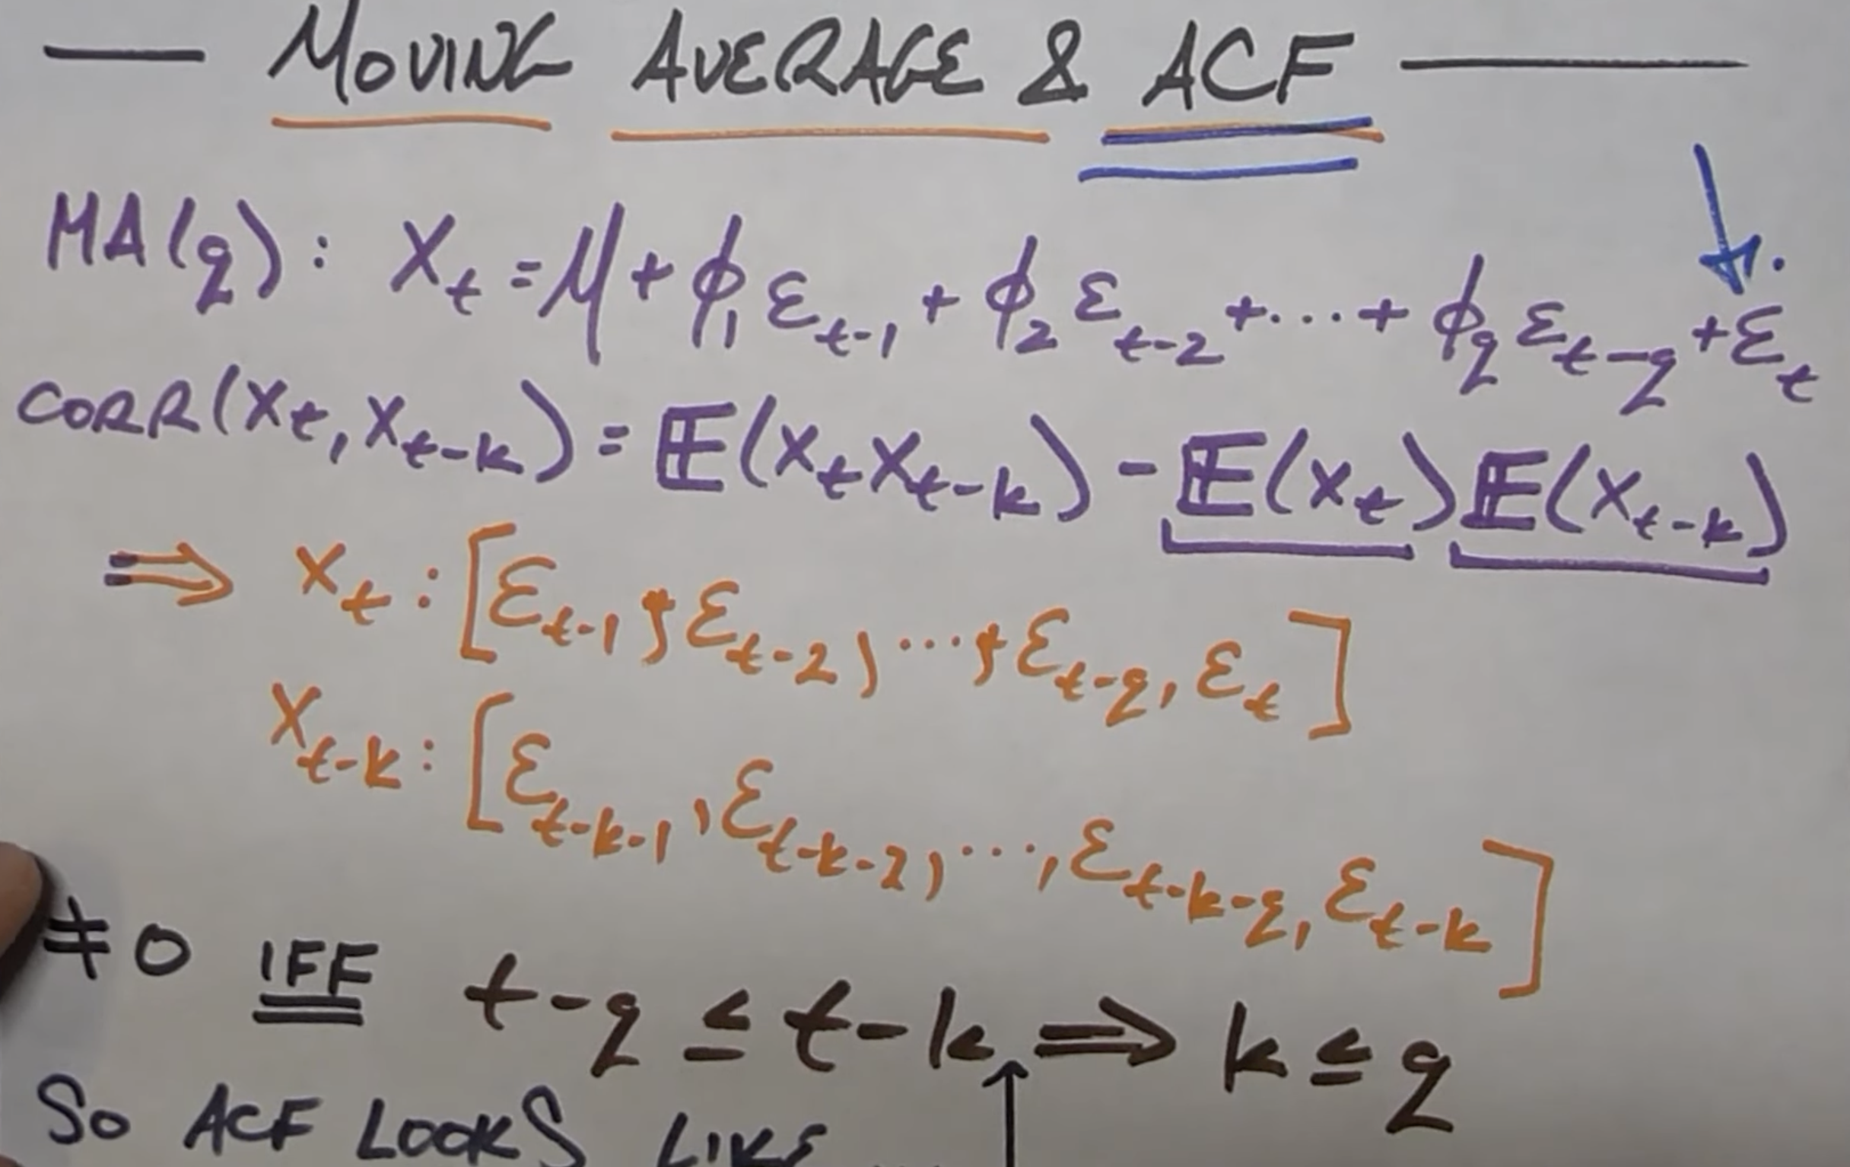

INVERTABILITY :

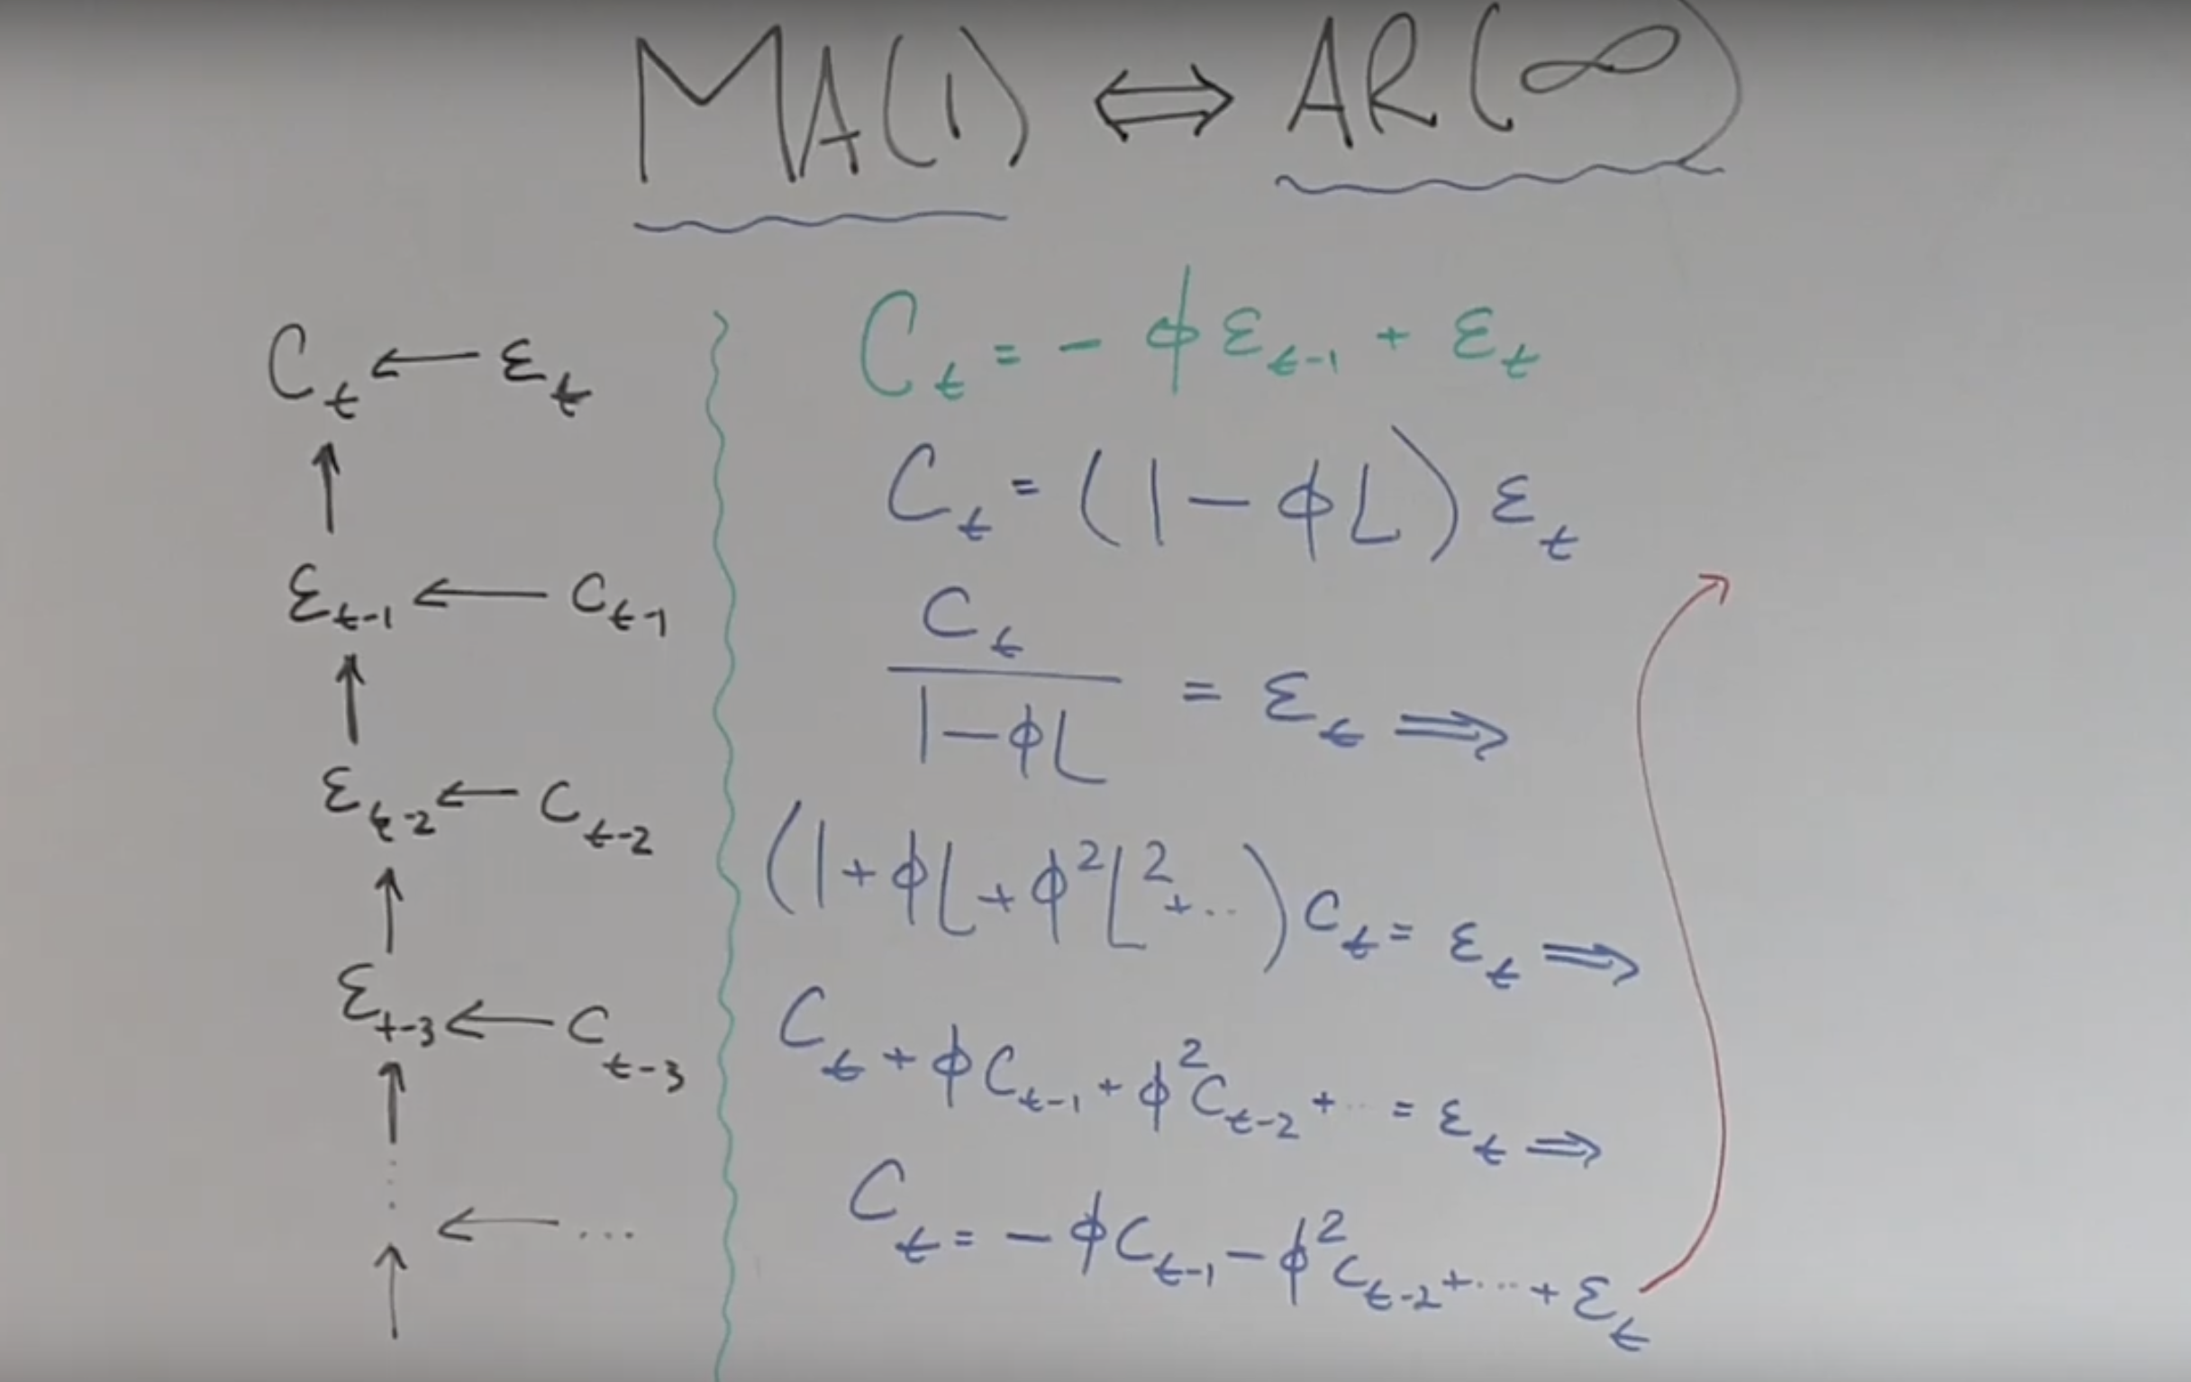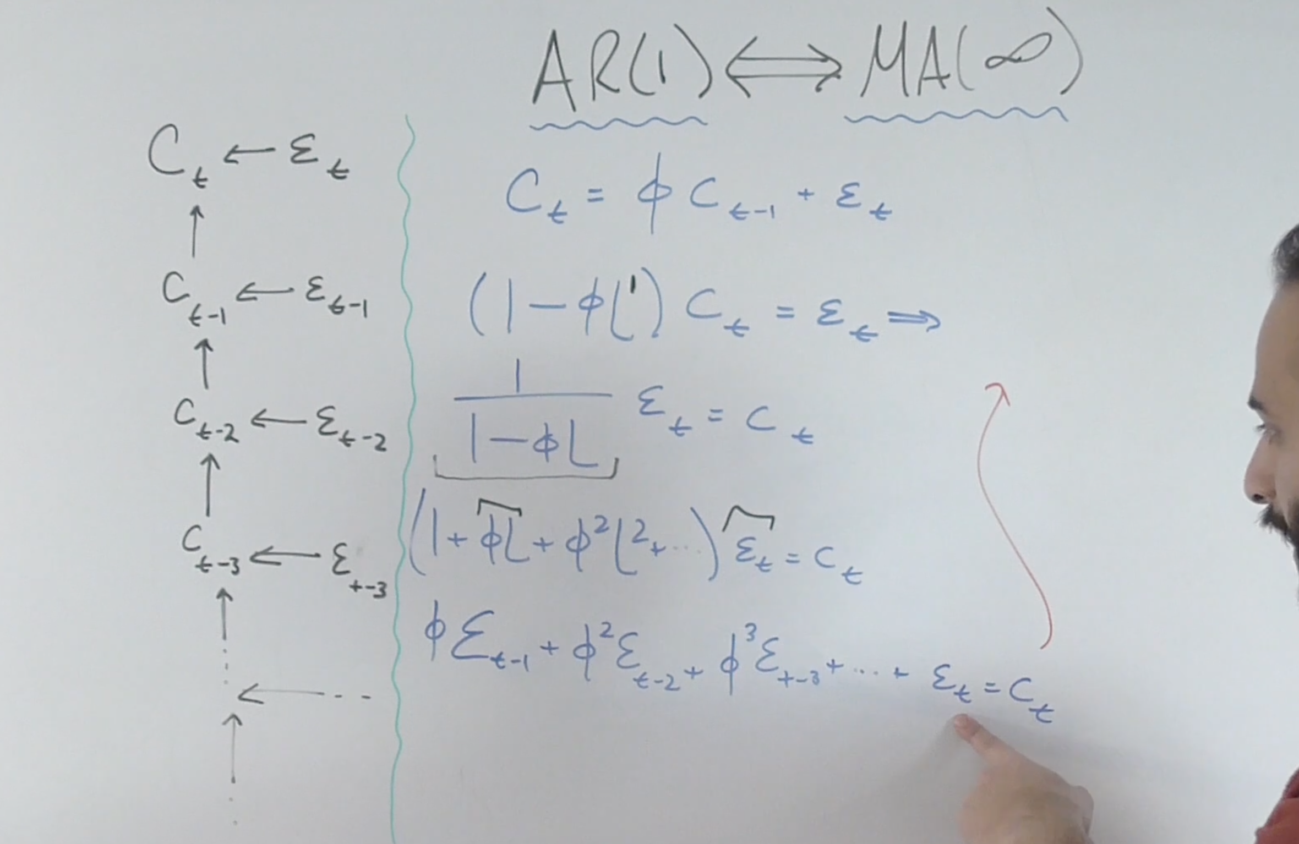

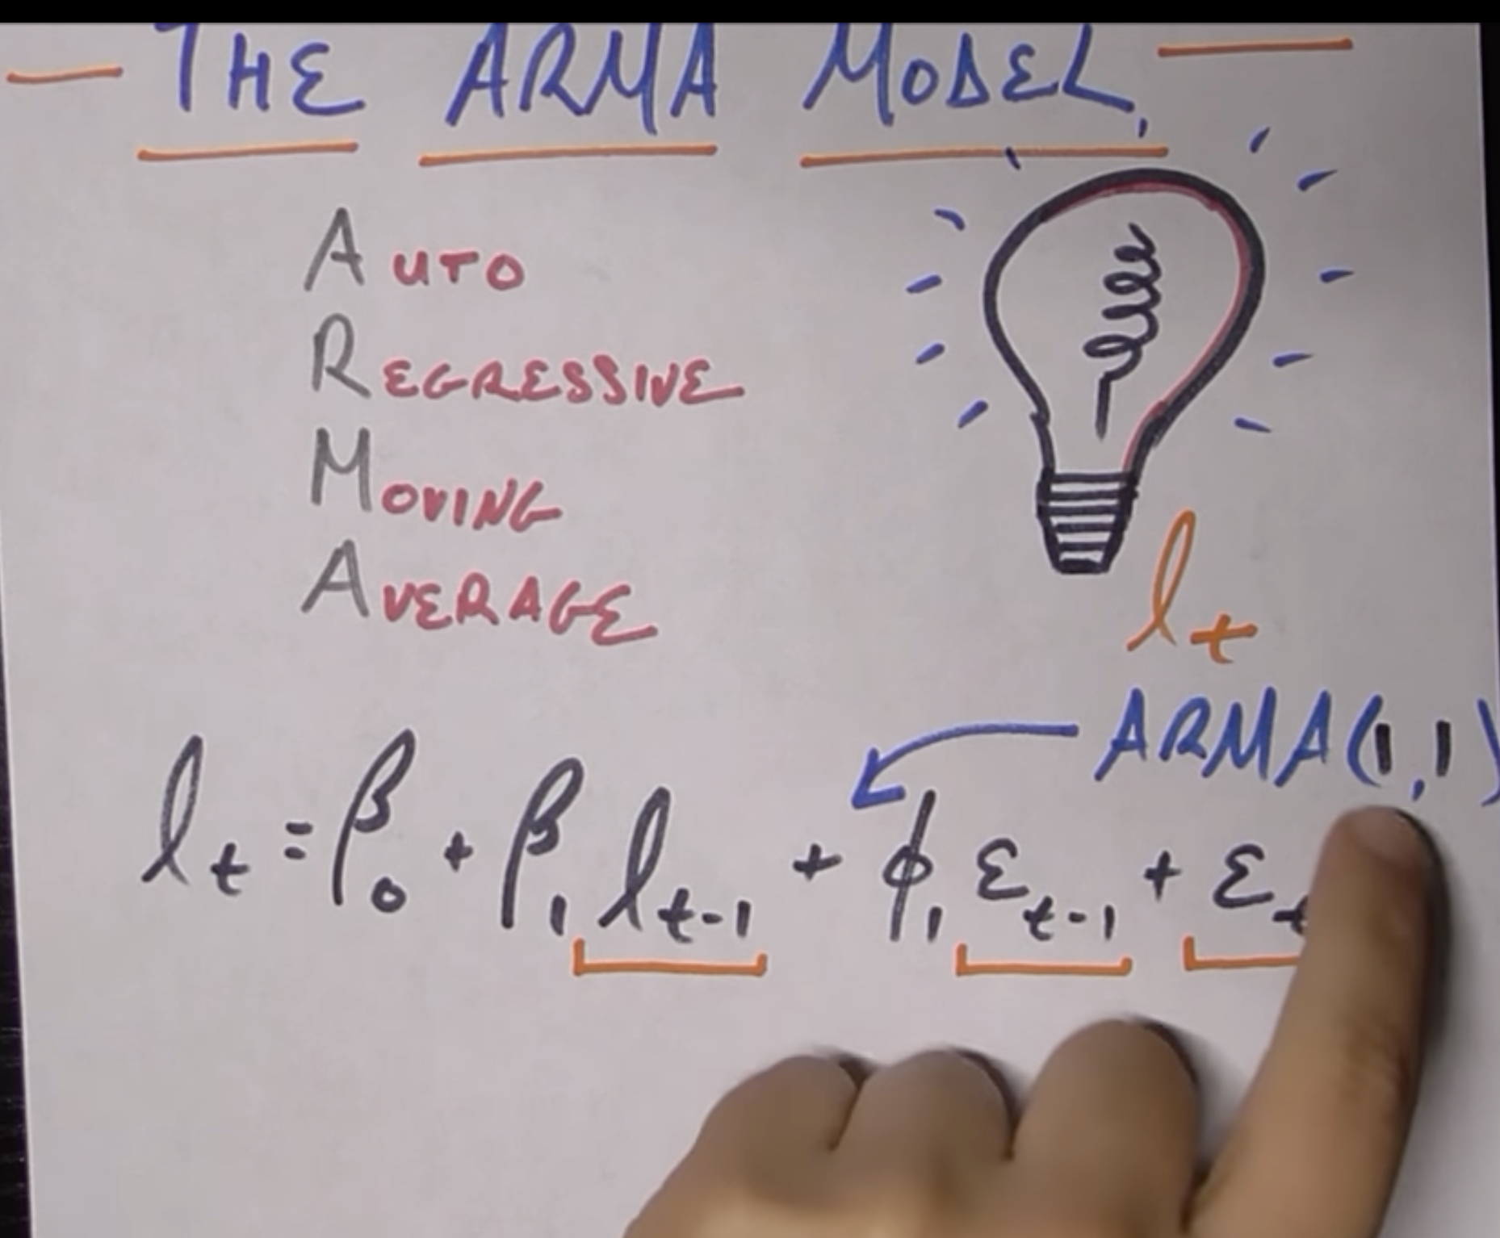

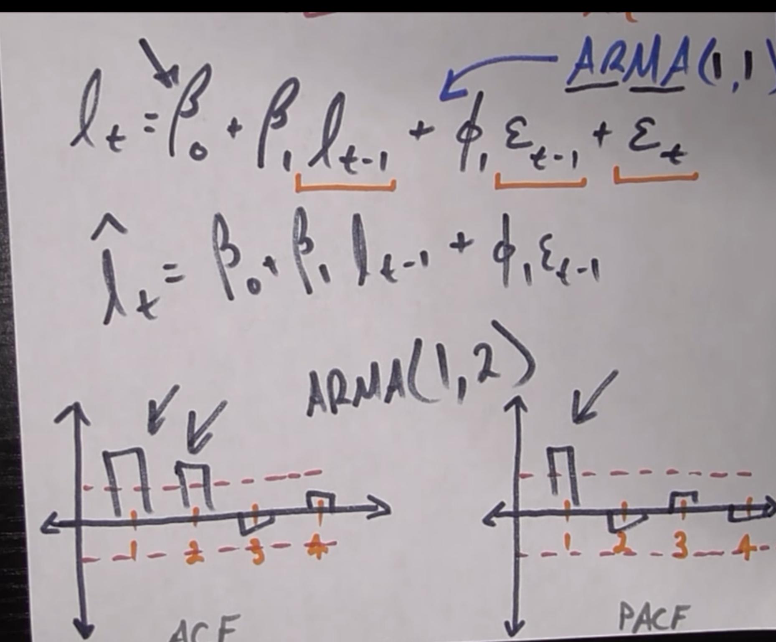

NOTE:

* To get best AR number look at the PACF.
* To get the best MA number look at the ACF.

ARIMA:

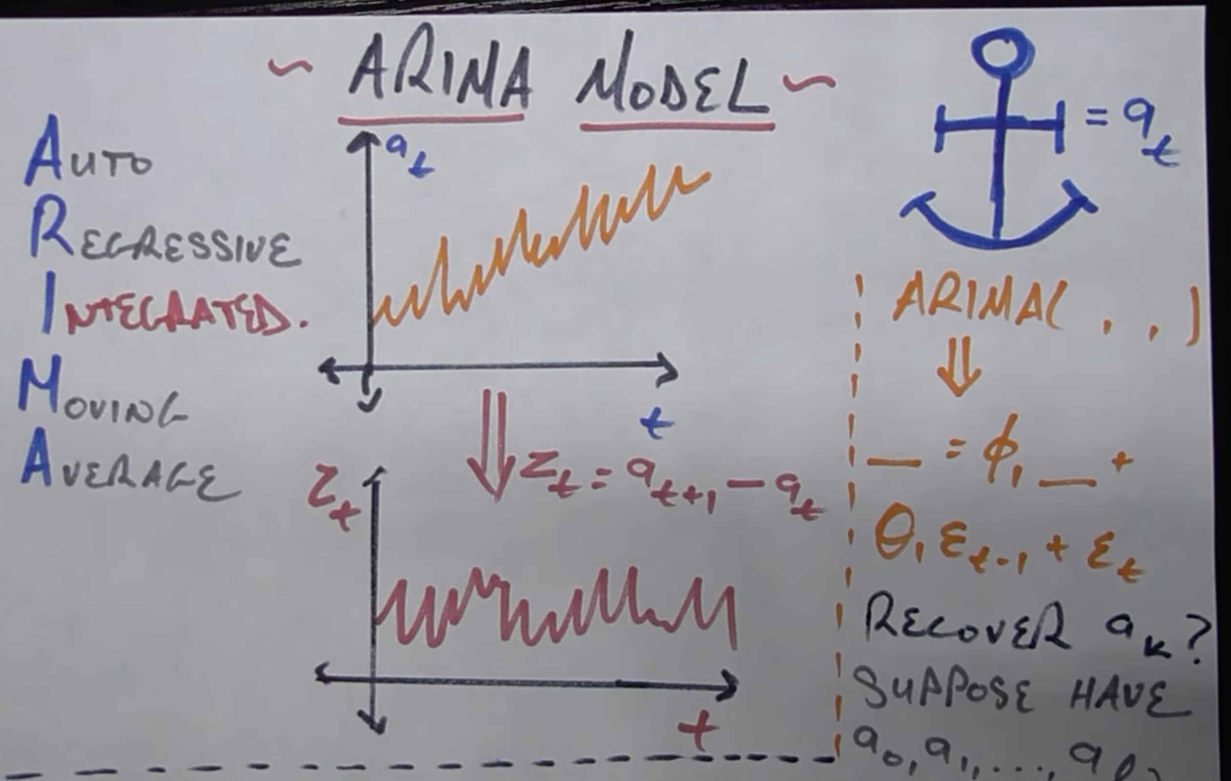

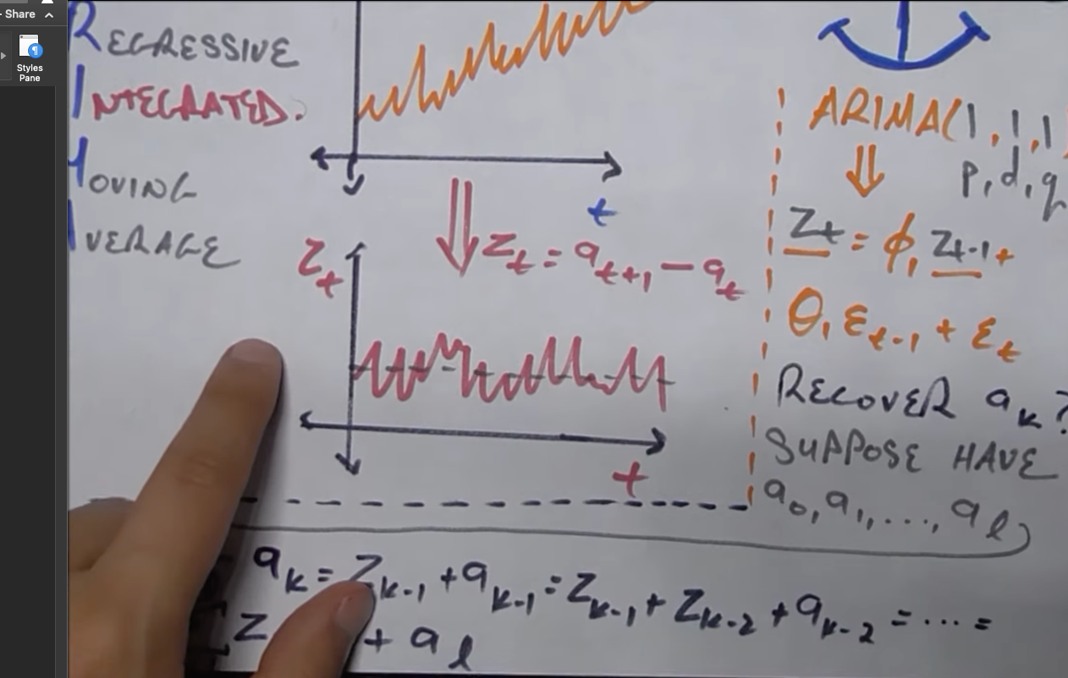



* How to get the d value, the smallest value where our series is stationary.

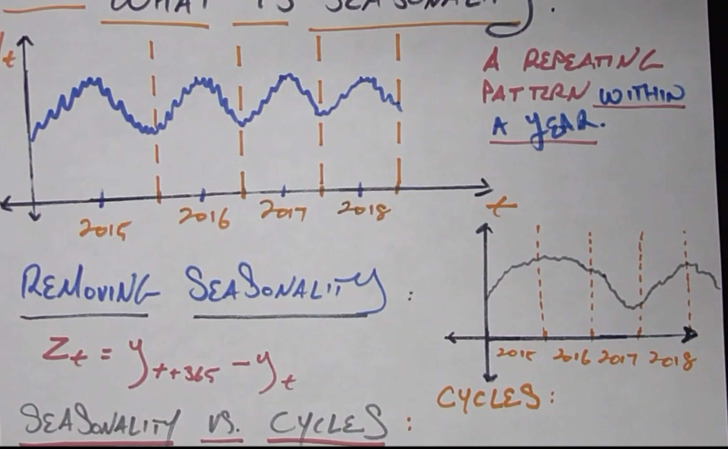

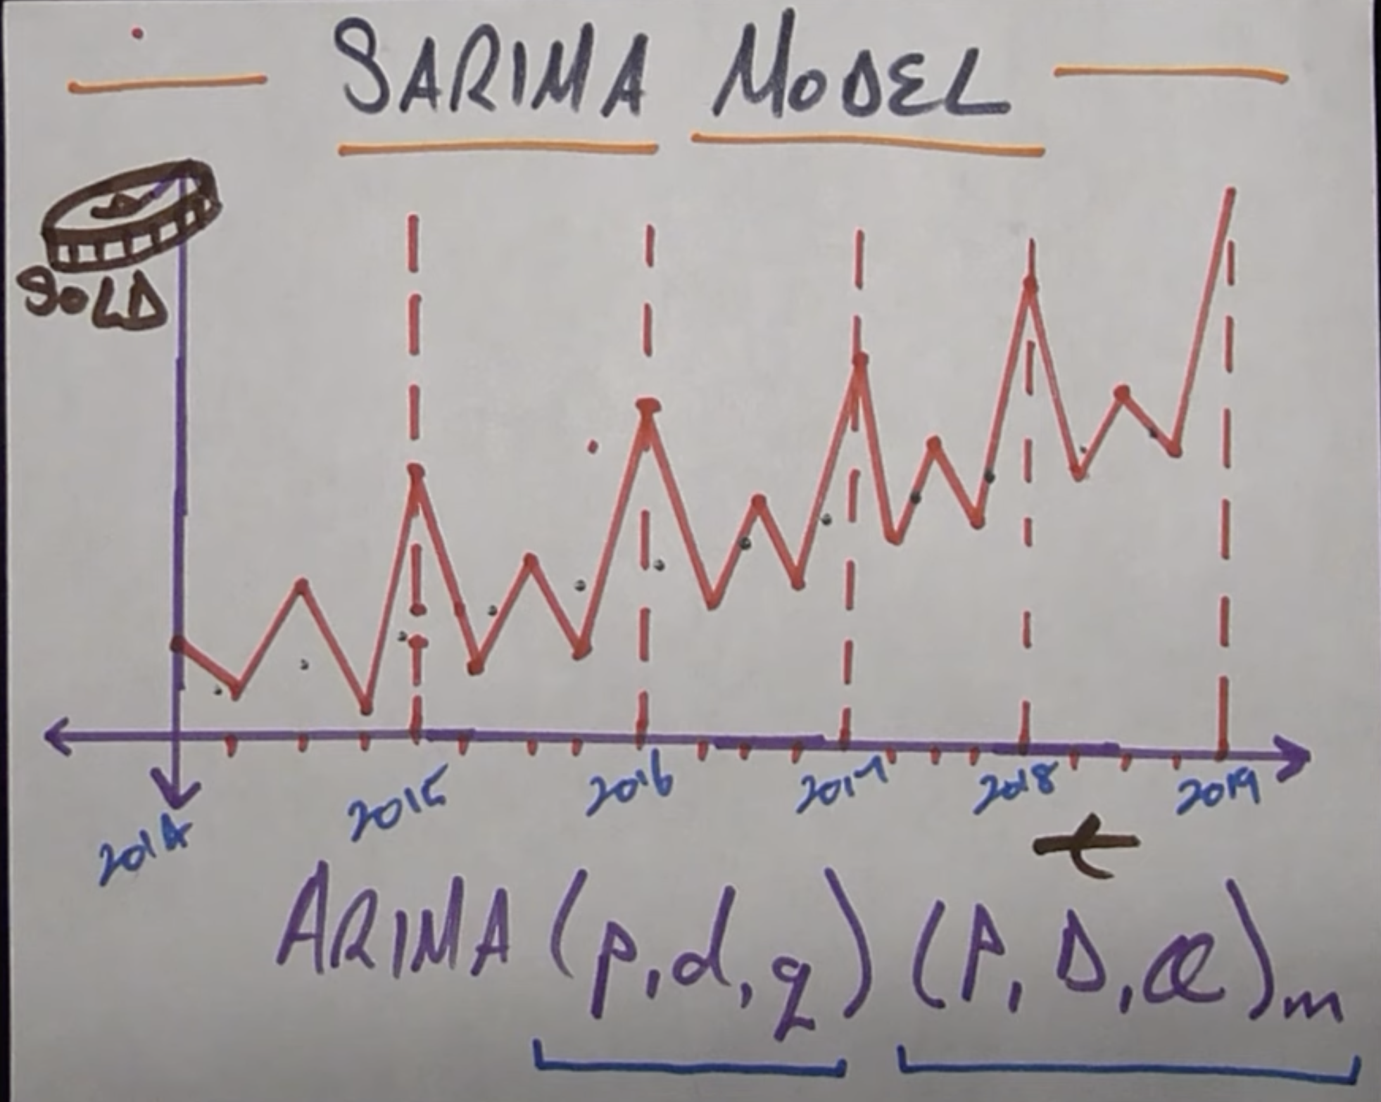

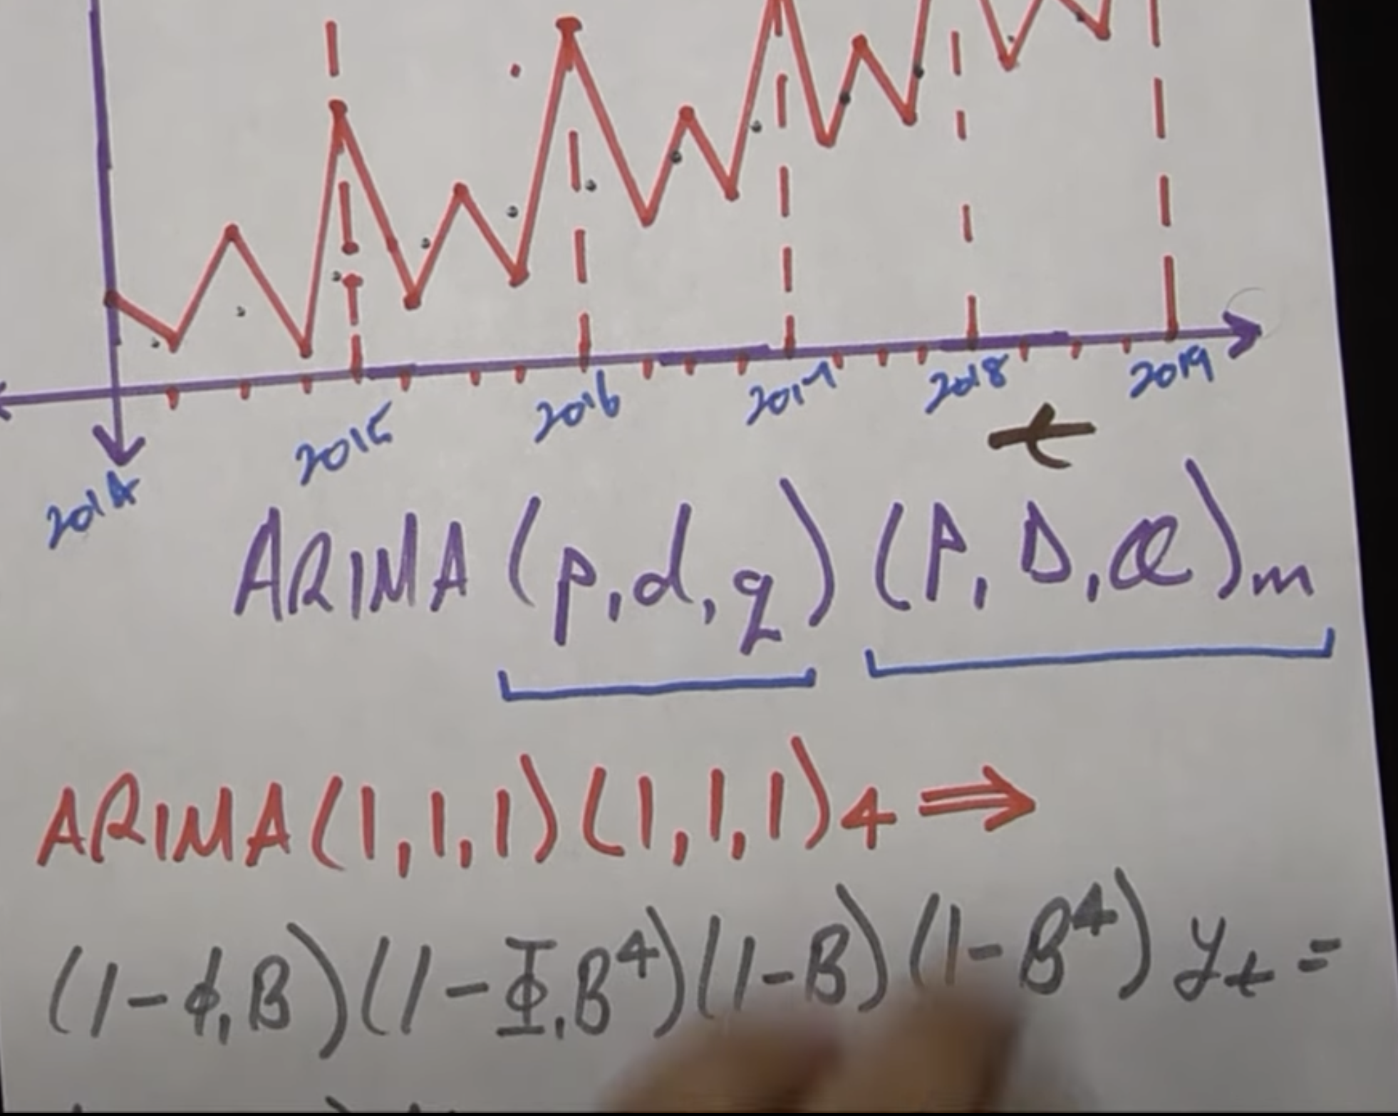

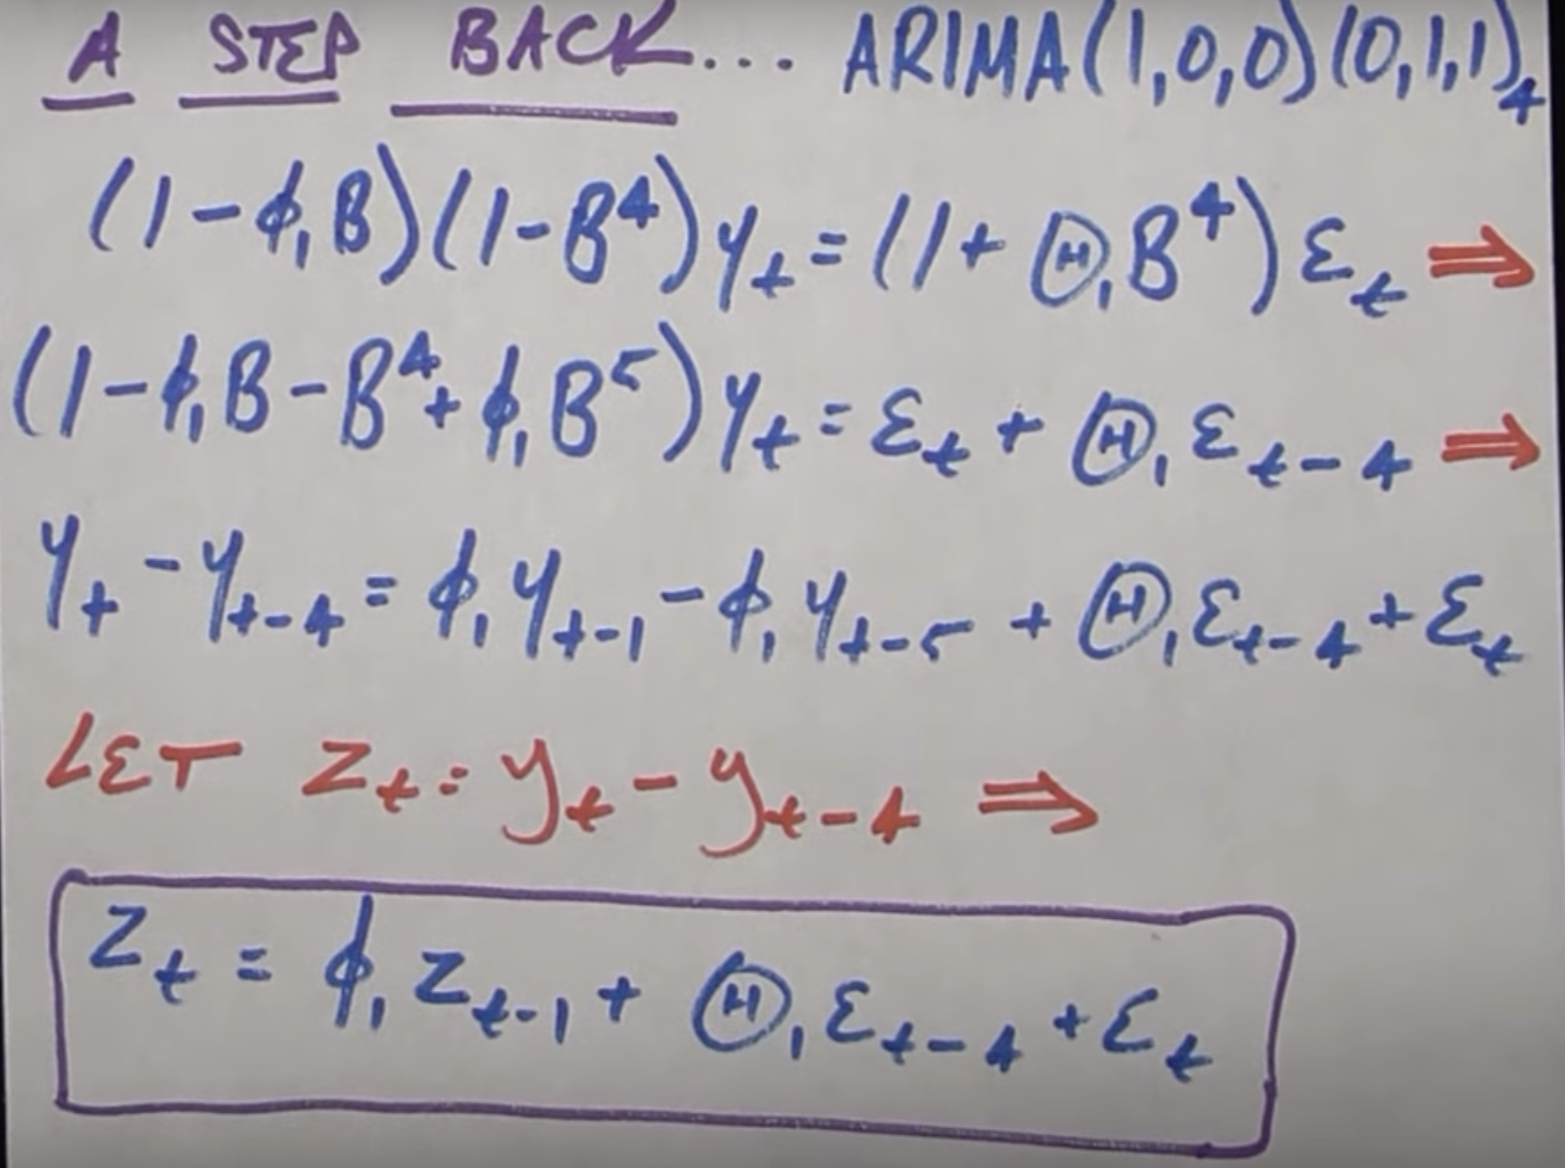

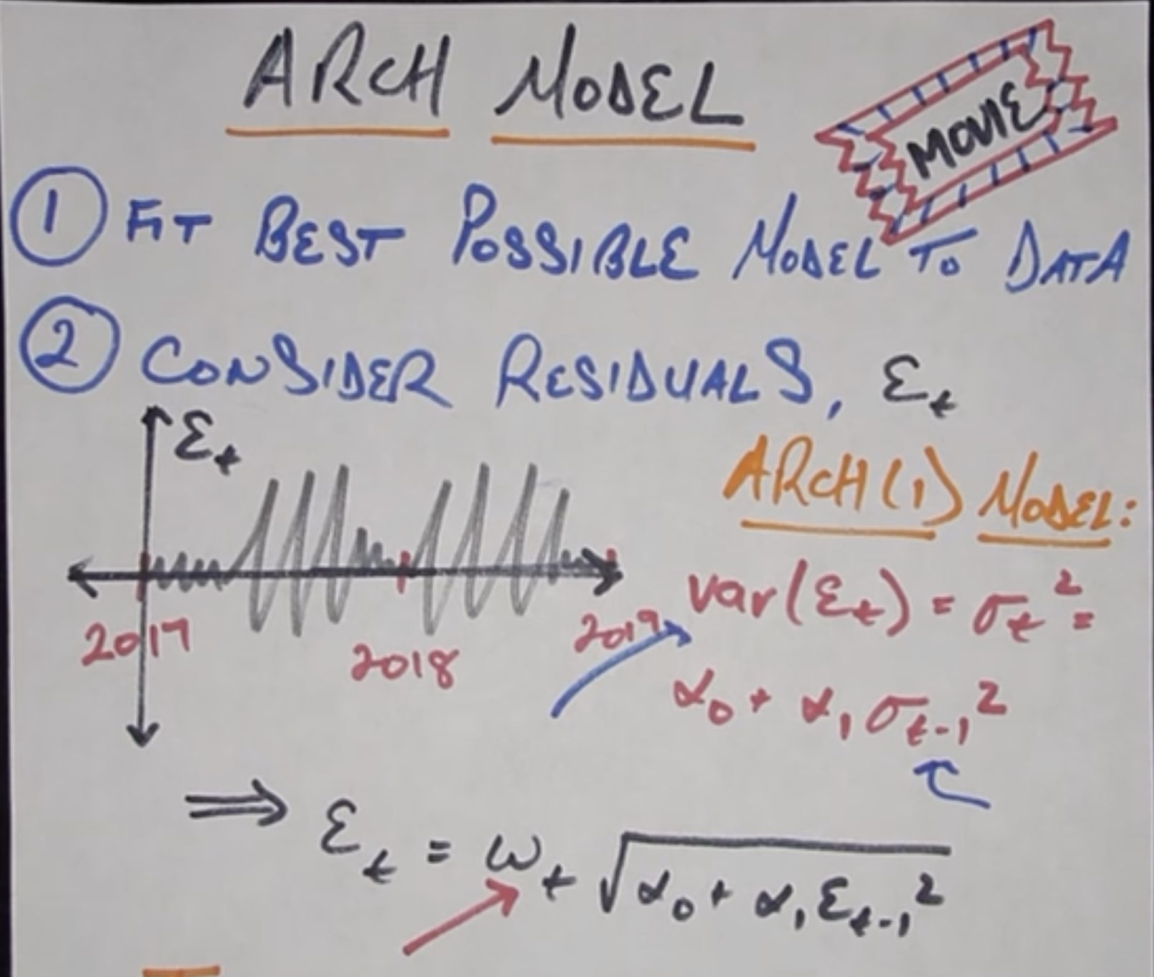

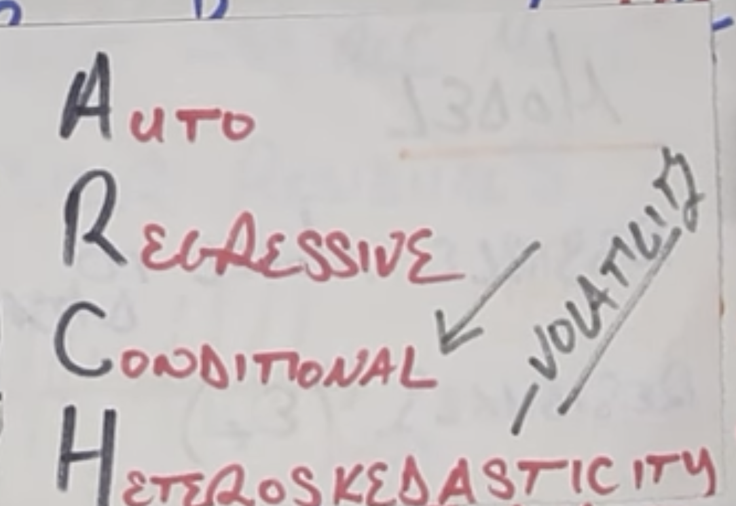

Time Series Analysis:

* Difference between regression and time series analysis, in time series we have only one variable to work with whereas in regression we have multiple variables available.
* What makes time series tough is

1. seasonality

2. trends

3. unexpected events

Rolling stats and stationery:

* Time series need to be stationary to apply ml model.

What is the stationary time series:

1. constant mean

2. constant variance

* What if time series is not stationary?

1. compute the rolling stats like moving average etc., and make it stationary.

2. Rolling stats smoothen the time series. and make the time series stationary.

Exponential Smoothing:

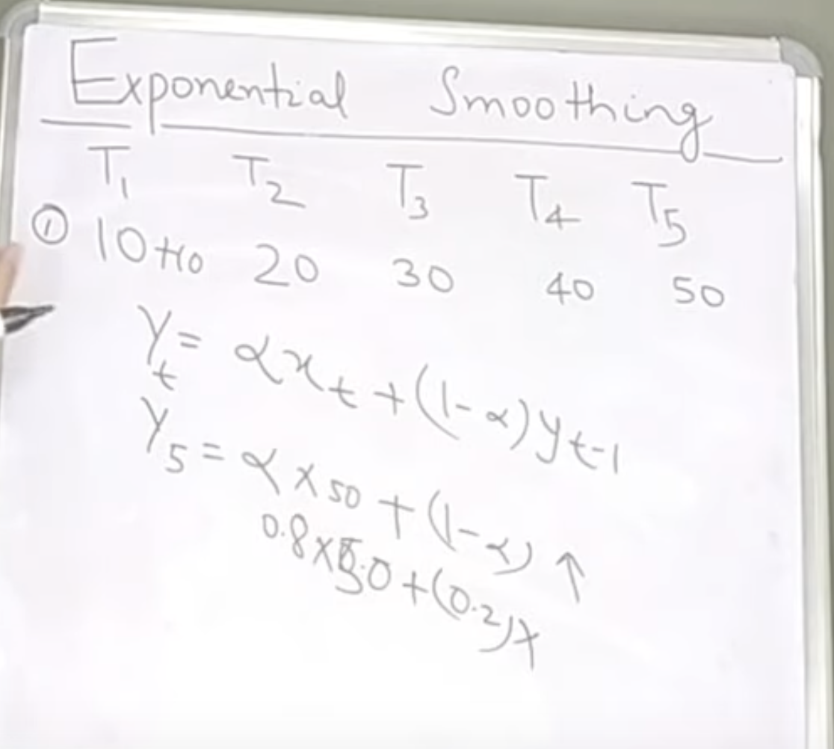

Double exponential smoothing:

* Captures Trend.

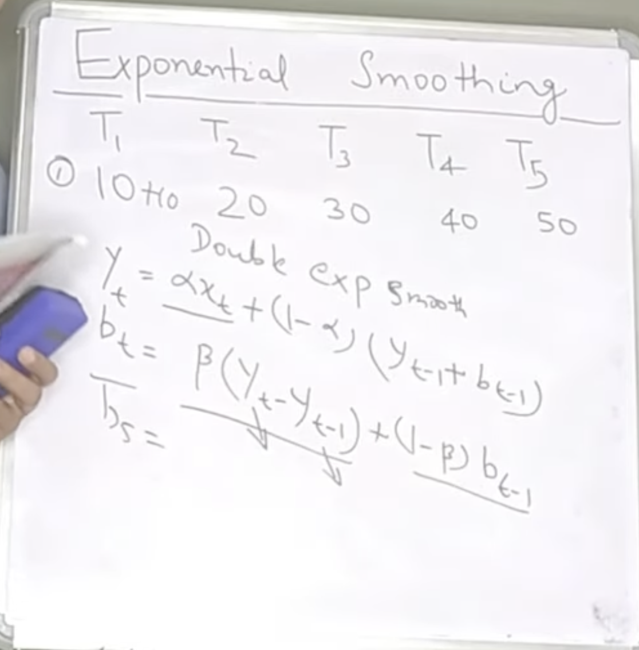

* Capturing the trend component using bt-1.

Triple exponential smoothing:

* Captures both trend and seasonality.

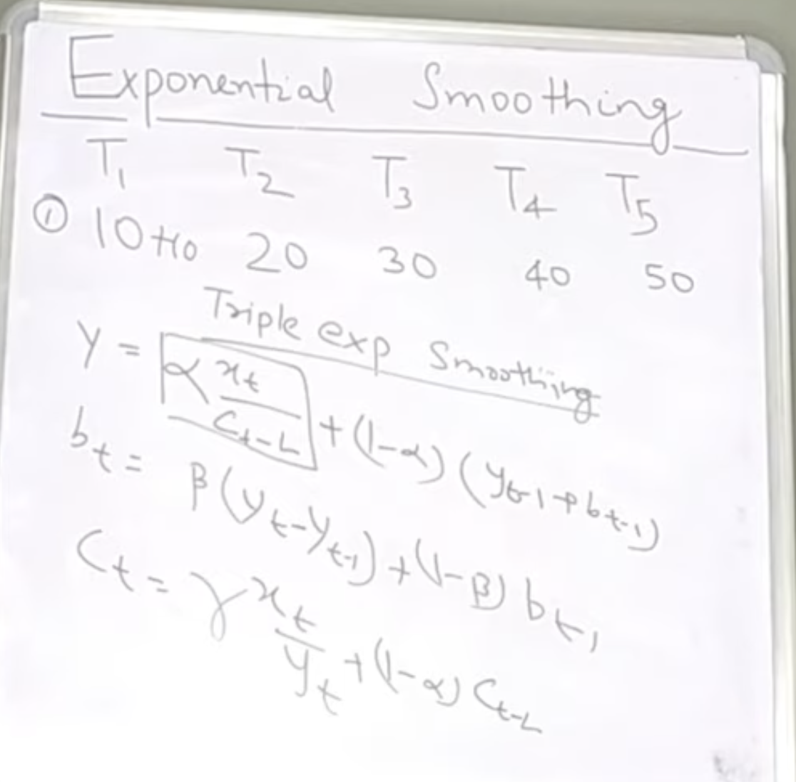

L – is the length of the seasonality

Ct – captures the seasonality component of data.